Elaboration Phase Specification CIS 320-02-4232

Team: TECKS

Kemo Camara, Ethan Epperson, Tanishq Malhotra, Chloe Salyer, Troy Smith

Tables of Contents:

System Requirements **2**

Use Case Descriptions, Use Case Diagrams, Sequence Diagrams **7**

Trace Matrix **83**

Class Diagram **84**

Database Diagram **86**

Database Definitions **87**

User Interface Navigation Diagram and Screen Layouts **96**

Data Capture Forms **97**

Data Presentation **107**

Gantt Chart **113**

Physical Architecture Design **114**

Design Procedures for Security Concerns and Non-Functional Requirements **115**

Elaboration Phase Prototypes **116**

**\* Page numbers may be altered due to OneDrive warping the formatting. We apologize if this is the case.**

System Requirements

Our system requirements describe the activities our system must be able to perform. These are the actions that we believe are crucial to include in our final product.

**Functional Requirements:**

Home Page Requirements

ID: SR001 – The home page will allow information to be edited.

ID: SR002 – The home page will allow messages to be created.

ID: SR003 – The home page will allow messages to be deleted.

ID: SR006 – The home page will allow reminders to be created.

ID: SR007 – The home page will allow reminders to be deleted.

Catapult Page Requirements

ID: SR008 – The Catapult page will allow CSV data to be input.

ID: SR009 - The Catapult page will allow data to be edited by those with admin access.

ID: SR010 - The Catapult page will allow data to be compared.

DARI Systems Page Requirements

ID: SR011– The DARI Systems page will allow CSV data to be input.

ID: SR012 - The DARI Systems page will allow data to be edited by those with admin access.

ID: SR013– The DARI Systems page will allow data to be compared.

Injury Records Page Requirements

ID: SR014 – The injury records page will allow CSV or Excel data to be input.

ID: SR015- The injury records page will allow data to be edited by those with admin access.

Hawkins Dynamic Page Requirements

ID: SR016 – The Hawkins Dynamic page will allow CSV data to be input.

ID: SR017 – The Hawkins Dynamic page will allow data to be edited by those with admin access.

Perch Velocity Page Requirements

ID: SR018 – The perch velocity page will allow TXT or CSV data to be input.

ID: SR019 – The perch velocity page will allow data to be edited by those with admin access.

Synergy Page Requirements

ID: SR020 – The synergy page will link to the synergy website login.

SmarterBase Page Requirements

ID: SR021 – The SmarterBase page will link to the SmarterBase website login.

KenPom Page Requirements

ID: SR022 – The KenPom page will allow data to be input.

ID: SR023 – The KenPom page will allow data to be edited by those with admin access.

Bart Page Requirements

ID: SR024 – The Bart page will allow data to be input.

ID: SR025 – The Bart page will allow data to be edited by those with admin access.

JustPlay Page Requirements

ID: SR028 – The JustPlay page will allow data to be input.

ID: SR029 – The JustPlay page will allow data to be edited by those with admin access.

Practice Box Scores Page Requirements

ID: SR030 – The practice box scores page will allow data to be input.

ID: SR031 – The practice box scores page will allow data to be edited by those with admin access.

Game Box Scores Page Requirements

ID: SR032 – The game box scores page will allow data to be input.

ID: SR033 – The game box scores page will allow data to be edited by those with admin access.

**Non-Functional Requirements:**

Performance Requirements

ID: SR034 – The website will load quickly.

ID: SR035 – The website will run with no errors.

ID: SR036 – The website will be updated as needed.

Security Requirements

ID: SR037 – The input data will backup automatically.

ID: SR038 – The data can be edited by those with admin access.

ID: SR039 – The data can be input by those with manager access.

ID: SR040 – The website can only be viewed by those with employee access or higher.

Capacity Requirements

ID: SR041 – The website will be able to handle large amounts of data input.

Availability Requirements

ID: SR042 – The website will always be accessible.

ID: SR043 – The website will be compatible with most web browsers.

ID: SR044 – The website will be compatible with most devices.

ID: SR045 – The website will adhere to W3C web accessibility standards.

Use Case Descriptions, Use Case Diagrams, Sequence Diagrams

**Use Case 1 Description**

|  |  |  |
| --- | --- | --- |
| Use Case Name: Edit Homepage Information | ID: 01 | Importance Level: Low |
| Primary Actor: Admin | | Use Case Type: Detail |
| Stakeholders and Interests:  Admin - wants to edit the design of the homepage  Website - tool used to hold player data | | |
| Brief Description: This use case describes how the home page can be edited | | |
| Trigger: Admin navigates to the home page on the website and clicks edit page.  Type: External | | |
| Relationships:  Association: Admin  Include:  Extend:  Generalization: Edit homepage | | |
| Normal Flow of Events:   1. The admin navigates to the homepage on the website. 2. The admin clicks the “Edit Homepage” button to edit the homepage. 3. The admin edits the necessary information on the home page. 4. The admin clicks the “Submit” button to process the edits. 5. The admin is directed to a webpage verifying that the edit was accepted. 6. An email is sent to the admin notifying them that the edit has been made. | | |
| SubFlows: | | |
| Alternate/Exceptional Flows:  4a. The edit was not processed.  5a. A pop-up message notifies the admin that the edit was not accepted and to try again.  6a. An email is sent to the admin notifying them that the edit was not made. | | |

**Use Case 1 Sequence Diagram**

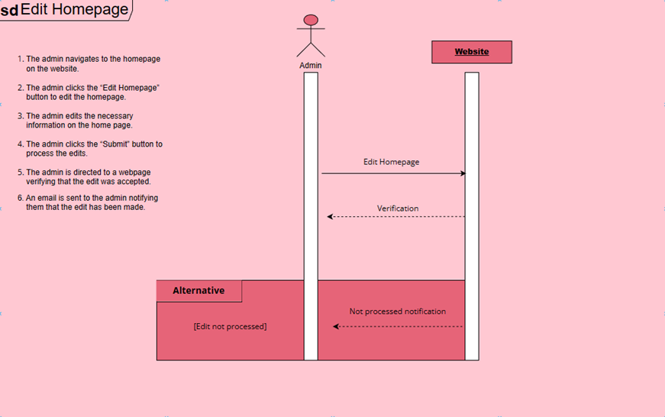

1. This use case is initiated when an administrator decides to edit information on the home page.
2. To perform this action, the administrator would access the content management system WordPress and change the information displayed to users.

**Use Case 1 Diagram**

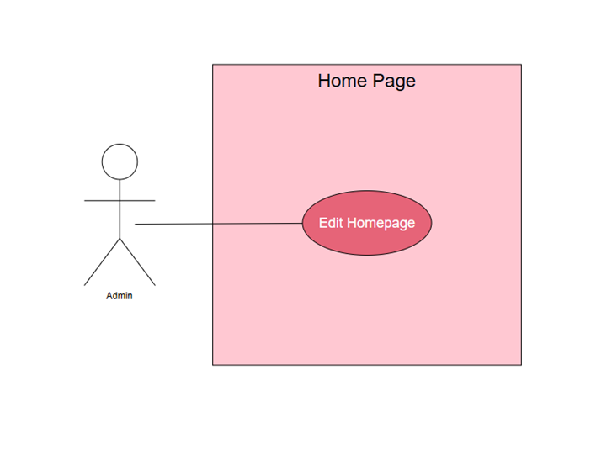

Narrative: The home page will allow website administrators to edit information.

**Use Case 2, 3, and 4 Description**

|  |  |  |
| --- | --- | --- |
| Use Case Name: Create Comment | ID: 02 | Importance Level: Low |
| Primary Actor: All Users | | Use Case Type: Detail |
| Stakeholders and Interests:  Admin - user may want to create a comment under a reminder post for all users to view.  Website - tool used to collect player data. | | |
| Brief Description: This use case describes how comments can be created. | | |
| Trigger: User navigates to the homepage on the website and clicks create comment.  Type: External | | |
| Relationships:  Association: Any User  Include:  Extend:  Generalization: Create Comment | | |
| Normal Flow of Events:   1. The user navigates to the homepage on the website. 2. The user clicks the “Create Comment” button to create a comment under a reminder. 3. The user adds the necessary information to the comment. 4. The user clicks the “Submit” button to create the comment. 5. The user is directed to a webpage verifying that the comment was accepted. 6. A confirmation email is sent to the user notifying them that the comment has been created. | | |
| SubFlows: | | |
| Alternate/Exceptional Flows:  5a. The comment was not created.  5b. A pop-up message notifies the user that the comment was not created and to try again.  6a. An email is sent to the user notifying them that the comment was not created. | | |

|  |  |  |
| --- | --- | --- |
| Use Case Name: Edit Comment | ID: 03 | Importance Level: Low |
| Primary Actor: All Users | | Use Case Type: Detail |
| Stakeholders and Interests:  Admin – admin may want to edit a comment.  Website - tool used to collect player data | | |
| Brief Description: This use case describes how comments can be edited. | | |
| Trigger: Admin navigates to the homepage on the website and clicks edit comment.  Type: External | | |
| Relationships:  Association: Admin  Include:  Extend:  Generalization: Edit Comment | | |
| Normal Flow of Events:   1. The user navigates to the homepage on the website. 2. The user clicks the “Edit Comment” button to edit comment information. 3. The user edits the necessary information in the comment. 4. The user clicks the “Submit” button to process the edit. 5. The user is directed to a webpage verifying that the edit was accepted. 6. A confirmation email is sent to the user notifying them that an edit has been made. | | |
| SubFlows: | | |
| Alternate/Exceptional Flows:  5a. The edit was not processed.  5b. A pop-up message notifies the user that the edit was not accepted and to try again.  6a. An email is sent to the user notifying them that the edit was not processed. | | |

|  |  |  |
| --- | --- | --- |
| Use Case Name: Delete Comment | ID: 04 | Importance Level: Low |
| Primary Actor: All Users | | Use Case Type: Detail |
| Stakeholders and Interests:  Any User - wants to delete a comment.  Website - tool used to hold player data | | |
| Brief Description: This use case describes how comments can be deleted. | | |
| Trigger: User navigates to the home page on the website and clicks delete comment.  Type: External | | |
| Relationships:  Association: Any User  Include:  Extend:  Generalization: Delete Comment | | |
| Normal Flow of Events:   1. The user navigates to the homepage on the website. 2. The user clicks the “Delete Comment” button to delete the reminder. 3. The user clicks the “Submit” button to process the deletion. 4. The user is directed to a webpage verifying that the deletion was accepted. 5. An email is sent to the user notifying them that the deletion has been made. | | |
| SubFlows: | | |
| Alternate/Exceptional Flows:  4a. The deletion was not processed.  5a. A pop-up message notifies the user that the deletion was not accepted and to try again.  6a. An email is sent to the user notifying them that the deletion was not made. | | |

**Use Case 2, 3 and 4 Sequence Diagram**

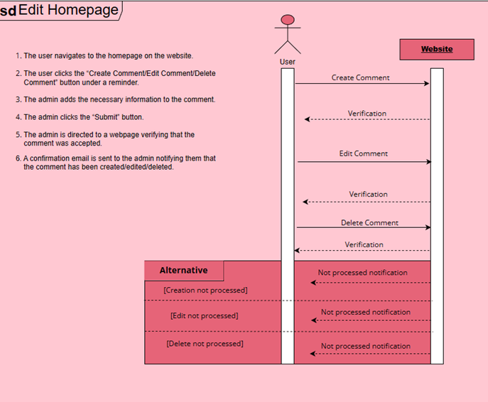

1. This use case is initiated when a user decides to add, edit, or delete a comment under a reminder post on the home page.
2. To perform this action, the user would access the content management system WordPress and add, edit, or delete a comment.

**Use Case 2, 3, and 4 Diagram**

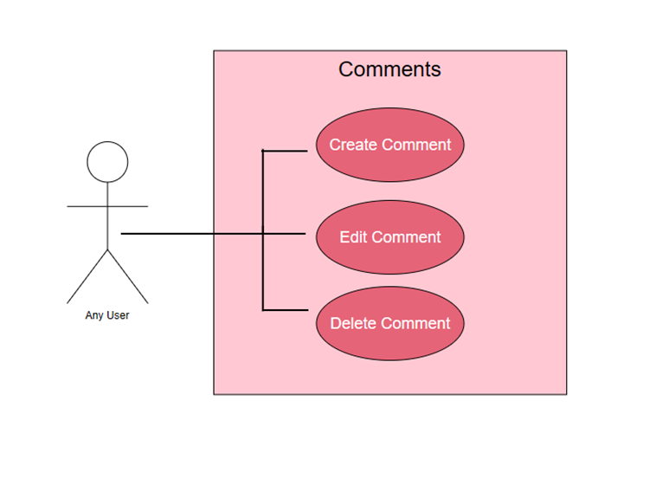

Narrative: Website users can create, edit, or delete comments on reminder posts.

**Use Case 5, 6, and 7 Description**

|  |  |  |
| --- | --- | --- |
| Use Case Name: Create Reminder Post | ID: 05 | Importance Level: Low |
| Primary Actor: Admin | | Use Case Type: Detail |
| Stakeholders and Interests:  Admin - admin may want to create a reminder post for all users to view.  Website - tool used to collect player data. | | |
| Brief Description: This use case describes how reminder posts can be created. | | |
| Trigger: Admin navigates to the homepage on the website and clicks create reminder.  Type: External | | |
| Relationships:  Association: Admin  Include:  Extend:  Generalization: Create Reminder | | |
| Normal Flow of Events:   1. The admin navigates to the homepage on the website. 2. The admin clicks the “Create Reminder” button to create a reminder. 3. The admin adds the necessary information to the reminder. 4. The admin clicks the “Submit” button to create the reminder. 5. The admin is directed to a webpage verifying that the reminder was accepted. 6. A confirmation email is sent to the admin notifying them that the reminder has been created. | | |
| SubFlows: | | |
| Alternate/Exceptional Flows:  5a. The reminder was not created.  5b. A pop-up message notifies the admin that the reminder was not created and to try again.  6a. An email is sent to the admin notifying them that the reminder was not created. | | |

|  |  |  |
| --- | --- | --- |
| Use Case Name: Edit Reminder Post | ID: 06 | Importance Level: Low |
| Primary Actor: Admin | | Use Case Type: Detail, Essential |
| Stakeholders and Interests:  Admin – admin may want to edit a reminder.  Website - tool used to collect player data | | |
| Brief Description: This use case describes how reminder posts can be edited. | | |
| Trigger: Admin navigates to the homepage on the website and clicks edit reminder.  Type: External | | |
| Relationships:  Association: Admin  Include:  Extend:  Generalization: Edit Reminder | | |
| Normal Flow of Events:   1. The admin navigates to the homepage on the website. 2. The admin clicks the “Edit Reminder” button to edit reminder information. 3. The admin edits the necessary information in the reminder. 4. The admin clicks the “Submit” button to process the edit. 5. The admin is directed to a webpage verifying that the edit was accepted. 6. A confirmation email is sent to the admin notifying them that an edit has been made. | | |
| SubFlows: | | |
| Alternate/Exceptional Flows:  5a. The edit was not processed.  5b. A pop-up message notifies the admin that the edit was not accepted and to try  again.  6a. An email is sent to the admin notifying them that the edit was not processed. | | |

|  |  |  |
| --- | --- | --- |
| Use Case Name: Delete Reminder | ID: 07 | Importance Level: Low |
| Primary Actor: Admin | | Use Case Type: Detail |
| Stakeholders and Interests:  Admin - wants to delete a reminder.  Website - tool used to hold player data | | |
| Brief Description: This use case describes how reminders can be deleted. | | |
| Trigger: Admin navigates to the home page on the website and clicks delete reminder.  Type: External | | |
| Relationships:  Association: Admin  Include:  Extend:  Generalization: Delete Reminder | | |
| Normal Flow of Events:   1. The admin navigates to the homepage on the website. 2. The admin clicks the “Delete Reminder” button to delete the reminder. 3. The admin clicks the “Submit” button to process the deletion. 4. The admin is directed to a webpage verifying that the deletion was accepted. 5. An email is sent to the admin notifying them that the deletion has been made. | | |
| SubFlows: | | |
| Alternate/Exceptional Flows:  4a. The deletion was not processed.  5a. A pop-up message notifies the admin that the deletion was not accepted and to try again.  6a. An email is sent to the admin notifying them that the deletion was not made. | | |

**Use Case 5, 6 and 7 Sequence Diagram**

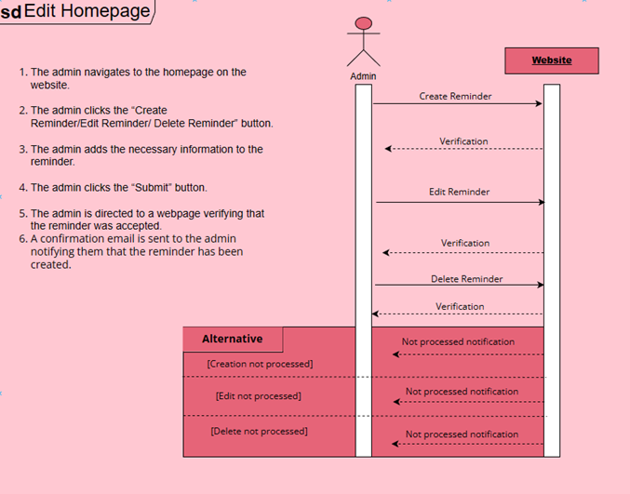

1. This use case is initiated when a administrator decides to add, edit, or delete a reminder post on the home page.
2. To peform this action, the administrator would access the content management system WordPress and add, edit, or delete a reminder post.

**Use Case 5, 6, and 7 Diagram**

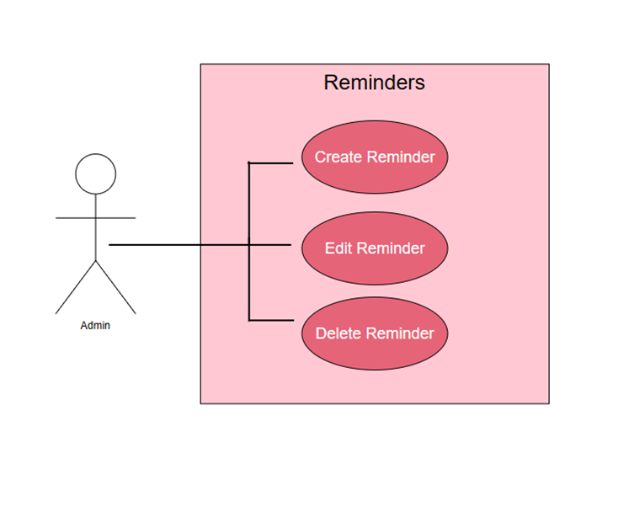

Narrative: Website administartors can create, edit, or delete reminder posts.

**Use Case 8 Description**

|  |  |  |
| --- | --- | --- |
| Use Case Name: Create Catapult Table | ID: 08 | Importance Level: High |
| Primary Actor: Admin | | Use Case Type: Detail, Essential |
| Stakeholders and Interests:  Admin - admin wants to create a catapult table.  Website - tool used to collect player data. | | |
| Brief Description: This use case describes how catapult tables can be created. | | |
| Trigger: Admin navigates to the catapult page on the website and clicks create table.  Type: External | | |
| Relationships:  Association: Admin  Include:  Extend:  Generalization: Create Catapult Table | | |
| Normal Flow of Events:   1. The admin navigates to the catapult page on the website. 2. The admin clicks the “Create Table” button to create a table. 3. The admin adds the necessary data to the table. 4. The admin clicks the “Submit” button to create the table. 5. The admin is directed to a webpage verifying that the table was accepted. 6. A confirmation email is sent to the admin notifying them that the table has been created. | | |
| SubFlows: | | |
| Alternate/Exceptional Flows:  5a. The table was not created.  5b. A pop-up message notifies the admin that the table was not created and to try again.  6a. An email is sent to the admin notifying them that the table was not created. | | |

**Use Case 8 Sequence Diagram**

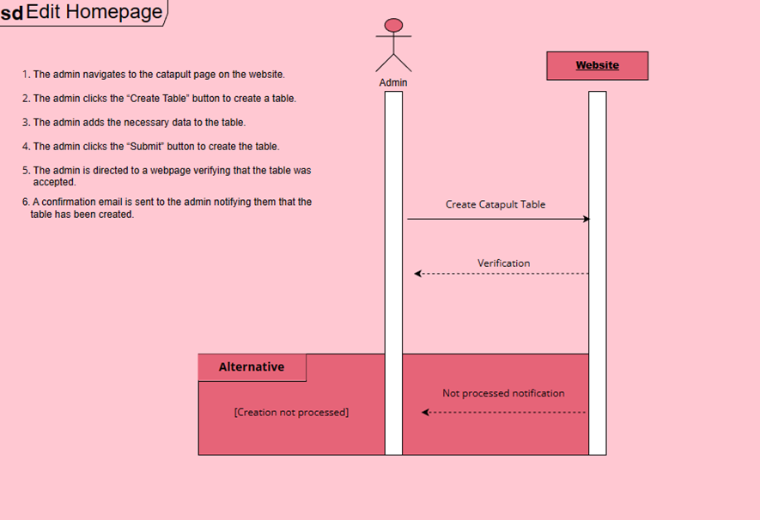

1. Administrator logs into WordPress.
2. Administrator accesses the ‘Catapult’ page and clicks edit.
3. The administrator inputs the CSV data into the catapult table.

**Use Case 8 Diagram**

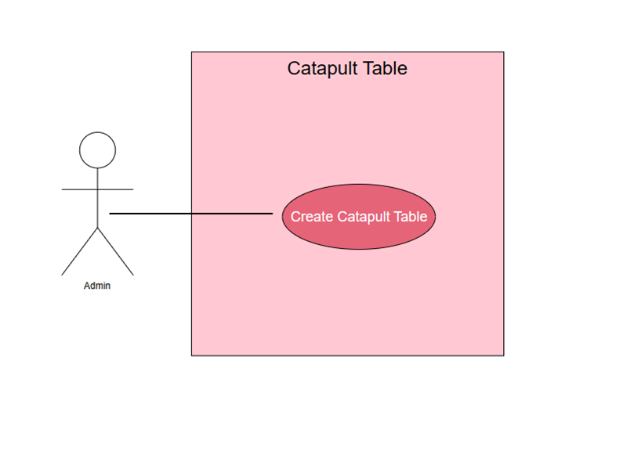

Narrative: The administrator is able to upload CSV data onto the catapult page.

**Use Case 9, 10, 11, and 12 Description**

|  |  |  |
| --- | --- | --- |
| Use Case Name: Create DARI Table | ID: 09 | Importance Level: High |
| Primary Actor: Employee | | Use Case Type: Detail, Essential |
| Stakeholders and Interests:  Justin Perez (director of men’s basketball administration) – importing and inputting player motion data into a table, editing table data, and analyzing table data.    Kenny Payne (head coach) – importing and inputting player motion data into a table, editing table data, analyzing table data, making decisions for the players with that table data.    Danny Manning, Nolan Smith, and Josh Jamieson (assistant coaches) - importing and inputting player motion data into a table, editing table data, analyzing table data, making decisions for the players with that table data.    Adam Petway (strength and conditioning coach) – importing and inputting player motion data into a table, editing table data, analyzing table data. | | |
| Brief Description: A table can be imported with DARI CSV data. | | |
| Trigger: User navigates to the Data Explorer tab of the WordPress Data Access Plugin and creates a table  Type: External | | |
| Relationships:  Association: Justin Perez, Kenny Payne, all assistant coaches, Adam Petway  Include: none  Extend: none  Generalization: none | | |
| Normal Flow of Events:   1. The user navigates to the WordPress Data Explorer with the WP Data Access Plugin installed. 2. The user clicks to upload a new CSV file. 3. The user navigates to the DARI CSV file they wish to upload. 4. User clicks to either import data or execute a script (A script that the SQL developer has created for them) 5. User navigates to the script to be executed for table creation. 6. User successfully imports the table data into the database using the script. 7. User defines which webpage the table should be linked to, in this case, the DARI page. 8. User applies this change. 9. User navigates to the DARI page and can now use the table directly from that page. | | |
| Sub Flows: | | |
| Alternate/Exceptional Flows:  4a. The user navigates to the Data Designer tab of the WP Data Access plugin tool.  5a. The user has a script generated for them and imports the CSV (this method is used if they do not decide to hire a WordPress developer, but we would recommend it)  again. | | |

­­­

|  |  |  |
| --- | --- | --- |
| Use Case Name: Create Injury Records Table | ID: 10 | Importance Level: High |
| Primary Actor: Employee | | Use Case Type: Detail, Essential |
| Stakeholders and Interests:  Justin Perez (director of men’s basketball administration) – importing and inputting player injury data into a table, editing table data, and analyzing table data.    Kenny Payne (head coach) – importing and inputting player injury data into a table, editing table data, analyzing table data, making decisions for the players with that table data.    Danny Manning, Nolan Smith, and Josh Jamieson (assistant coaches) - importing and inputting player injury data into a table, editing table data, analyzing table data, making decisions for the players with that table data.    DeVante Frazier (director of sports medicine/men’s basketball) – importing and inputting player injury data into a table, editing table data, analyzing table data. | | |
| Brief Description: A table can be imported with Injury Records CSV data. | | |
| Trigger: User navigates to the Data Explorer tab of the WordPress Data Access Plugin and creates a table  Type: External | | |
| Relationships:  Association: Justin Perez, Kenny Payne, all assistant coaches, DeVante Frazier  Include: none  Extend: none  Generalization: none | | |
| Normal Flow of Events:   1. The user navigates to the WordPress Data Explorer with the WP Data Access Plugin installed. 2. The user clicks to upload a new CSV file. 3. The user navigates to the Injury Records CSV file they wish to upload. 4. User clicks to either import data or execute a script (A script that the SQL developer has created for them) 5. User navigates to the script to be executed for table creation. 6. User successfully imports the table data into the database using the script. 7. User defines which webpage the table should be linked to, in this case, the Injury Records page. 8. User applies this change. 9. User navigates to the Injury Records page and can now use the table directly from that page. | | |
| SubFlows: | | |
| Alternate/Exceptional Flows:  4a. The user navigates to the Data Designer tab of the WP Data Access plugin tool.  5a. The user has a script generated for them and imports the CSV (this method is used if they do not decide to hire a WordPress developer, but we would recommend it)  again. | | |

|  |  |  |
| --- | --- | --- |
| Use Case Name: Create Hawkins Dynamic Table | ID: 11 | Importance Level: High |
| Primary Actor: Employee | | Use Case Type: Detail, Essential |
| Stakeholders and Interests:  Justin Perez (director of men’s basketball administration) – importing and inputting player force plate data into a table, editing table data, and analyzing table data.    Kenny Payne (head coach) – importing and inputting player force plate data into a table, editing table data, analyzing table data, making decisions for the players with that table data.    Danny Manning, Nolan Smith, and Josh Jamieson (assistant coaches) - importing and inputting player force plate data into a table, editing table data, analyzing table data, making decisions for the players with that table data.    Adam Petway (strength and conditioning coach) – importing and inputting player force plate data into a table, editing table data, analyzing table data. | | |
| Brief Description: A table can be imported with Hawkins Dynamic CSV data. | | |
| Trigger: User navigates to the Data Explorer tab of the WordPress Data Access Plugin and creates a table  Type: External | | |
| Relationships:  Association: Justin Perez, Kenny Payne, all assistant coaches, Adam Petway  Include: none  Extend: none  Generalization: none | | |
| Normal Flow of Events:   1. The user navigates to the WordPress Data Explorer with the WP Data Access Plugin installed. 2. The user clicks to upload a new CSV file. 3. The user navigates to the Hawkins Dynamic CSV file they wish to upload. 4. User clicks to either import data or execute a script (A script that the SQL developer has created for them) 5. User navigates to the script to be executed for table creation. 6. User successfully imports the table data into the database using the script. 7. User defines which webpage the table should be linked to, in this case, the Hawkins Dynamic page. 8. User applies this change. 9. User navigates to the Hawkins Dynamic page and can now use the table directly from that page. | | |
| SubFlows: | | |
| Alternate/Exceptional Flows:  4a. The user navigates to the Data Designer tab of the WP Data Access plugin tool.  5a. The user has a script generated for them and imports the CSV (this method is used if they do not decide to hire a WordPress developer, but we would recommend it)  again. | | |

|  |  |  |
| --- | --- | --- |
| Use Case Name: Create Perch Velocity Table | ID: 12 | Importance Level: High |
| Primary Actor: Employee | | Use Case Type: Detail, Essential |
| Stakeholders and Interests:  Justin Perez (director of men’s basketball administration) – importing and inputting player velocity training data into a table, editing table data, and analyzing table data.    Kenny Payne (head coach) – importing and inputting player velocity training data into a table, editing table data, analyzing table data, making decisions for the players with that table data.    Danny Manning, Nolan Smith, and Josh Jamieson (assistant coaches) - importing and inputting player velocity training data into a table, editing table data, analyzing table data, making decisions for the players with that table data.    Adam Petway (strength and conditioning coach) – importing and inputting player velocity training data into a table, editing table data, analyzing table data. | | |
| Brief Description: A table can be imported with Force Velocity CSV data. | | |
| Trigger: User navigates to the Data Explorer tab of the WordPress Data Access Plugin and creates a table  Type: External | | |
| Relationships:  Association: Justin Perez, Kenny Payne, all assistant coaches, Adam Petway  Include: none  Extend: none  Generalization: none | | |
| Normal Flow of Events:   1. The user navigates to the WordPress Data Explorer with the WP Data Access Plugin installed. 2. The user clicks to upload a new CSV file. 3. The user navigates to the Perch Velocity CSV file they wish to upload. 4. User clicks to either import data or execute a script (A script that the SQL developer has created for them) 5. User navigates to the script to be executed for table creation. 6. User successfully imports the table data into the database using the script. 7. User defines which webpage the table should be linked to, in this case, the Perch Velocity page. 8. User applies this change. 9. User navigates to the Perch Velocity page and can now use the table directly from that page. | | |
| SubFlows: | | |
| Alternate/Exceptional Flows:  4a. The user navigates to the Data Designer tab of the WP Data Access plugin tool.  5a. The user has a script generated for them and imports the CSV (this method is used if they do not decide to hire a WordPress developer, but we would recommend it)  again. | | |

**Use Case 9, 10, 11, and 12 Sequence Diagram**

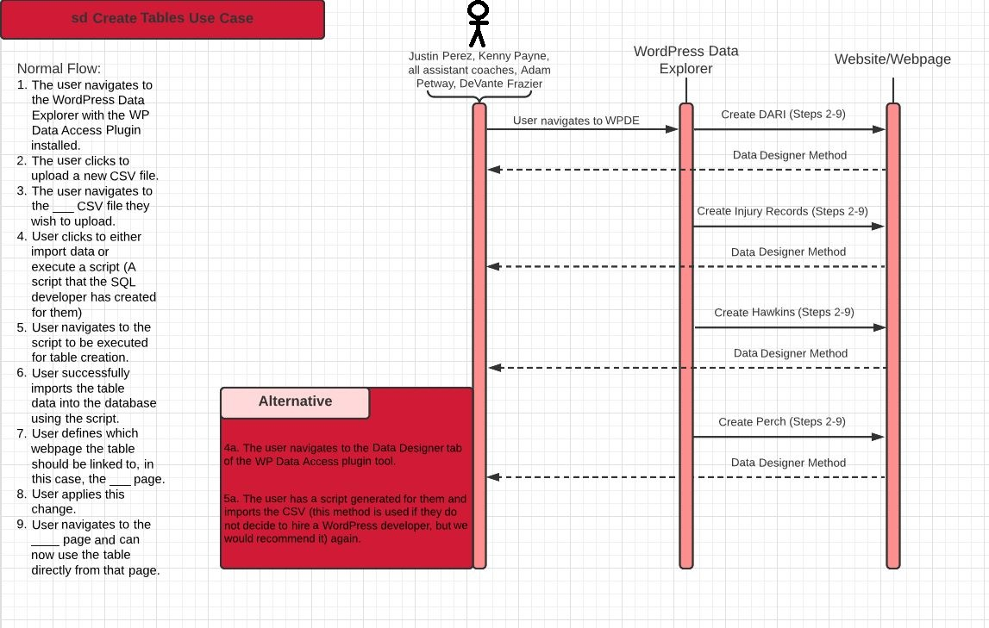

1. Any user or admin logs into the website

2. The user goes to the WPDE plugin

3. The use creates any number of the specified tables

4. The table appears on its related page

**Use Case 9, 10, 11, and 12 Diagram**

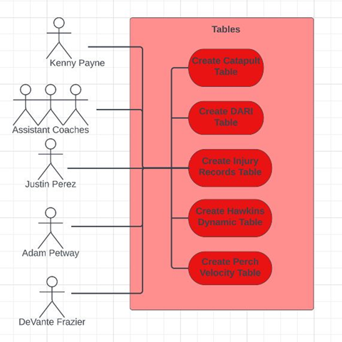

Narrative: Admins and users (Coaches and directors) can create tables for the Catapult, Dari, Injury Records, Hawkins Dynamic, and Perch Velocity webpages.

**Use case 13, 14, and 15 Descriptions**

|  |  |  |
| --- | --- | --- |
| Use Case Name: Create New Field | ID: 13 | Importance Level: High |
| Primary Actor: Employee | | Use Case Type: Detail, Essential |
| Stakeholders and Interests:  Justin Perez (director of men’s basketball administration) – can create new fields and name new fields.    Kenny Payne (head coach) – can create new fields and name new fields.    Danny Manning, Nolan Smith, and Josh Jamieson (assistant coaches) - can create new fields and name new fields.    Adam Petway (strength and conditioning coach) – can create new fields and name new fields.    DeVante Frazier (director of sports medicine/men’s basketball) – can create new fields and name new fields. | | |
| Brief Description: A user can create a new field within an existing table | | |
| Trigger: The user adds a new field with the sheet editor plugin and enters data into the field  Type: External | | |
| Relationships:  Association: Justin Perez, Kenny Payne, all assistant coaches, Adam Petway, DeVante Frazier  Include:  Extend: edit field, delete field  Generalization: | | |
| Normal Flow of Events:   1. A user with the WordPress sheet editor plugin installed navigates to the desired CSV table. 2. The user adds a new empty field. 3. The field is created with the given title. 4. The user enters their data into the field. | | |
| Sub Flows:   * 1. The user designates a field name/title.   3-1. The field is populated with an ID as well as other identifying data. | | |
| Alternate/Exceptional Flows: | | |

|  |  |  |
| --- | --- | --- |
| Use Case Name: Edit Field | ID: 14 | Importance Level: Low |
| Primary Actor: Administrator | | Use Case Type: Detail, Essential |
| Stakeholders and Interests:  Justin Perez (director of men’s basketball administration) – can edit fields and rename fields.    Kenny Payne (head coach) – can edit fields and rename fields.      Danny Manning, Nolan Smith, and Josh Jamieson (assistant coaches) - can edit fields and rename fields. | | |
| Brief Description: A user can edit a field within an existing table | | |
| Trigger: The user edits a field with the sheet editor plugin  Type: External | | |
| Relationships:  Association: Justin Perez, Kenny Payne, all assistant coaches  Include:  Extend:  Generalization: create field | | |
| Normal Flow of Events:   1. A user with the WordPress sheet editor plugin installed navigates to the desired CSV table. 2. The user goes to edit an existing field. 3. The user removes data from the field and adds new data. 4. The field is successfully edited. | | |
| Sub Flows:   * 1. The user re-designates a field name/title.   3-1. The field is populated with an ID as well as other identifying data. | | |
| Alternate/Exceptional Flows:  2a. The user is denied permission to edit the field if they are not an admin | | |

|  |  |  |
| --- | --- | --- |
| Use Case Name: Delete Field | ID: 15 | Importance Level: Low |
| Primary Actor: Administrator | | Use Case Type: Detail, Essential |
| Stakeholders and Interests:  Justin Perez (director of men’s basketball administration) – can delete existing fields.    Kenny Payne (head coach) – can delete existing fields.    Danny Manning, Nolan Smith, and Josh Jamieson (assistant coaches) - can delete existing fields. | | |
| Brief Description: A user can delete an existing field. | | |
| Trigger: The user deletes a field with the sheet editor plugin  Type: External | | |
| Relationships:  Association: Justin Perez, Kenny Payne, all assistant coaches  Include:  Extend:  Generalization: create donation | | |
| Normal Flow of Events:   1. A user with the WordPress sheet editor plugin installed navigates to the desired CSV table. 2. The user goes to delete an existing field. 3. The user attempts to delete a field. 4. The field is successfully deleted. | | |
| Sub Flows:  2-1. The user is prompted by a warning message asking them to reconfirm their decision | | |
| Alternate/Exceptional Flows:  2a. The user is denied permission to delete the field if they are not an admin | | |

**Use Case 13, 14, and 15 Sequence Diagram**

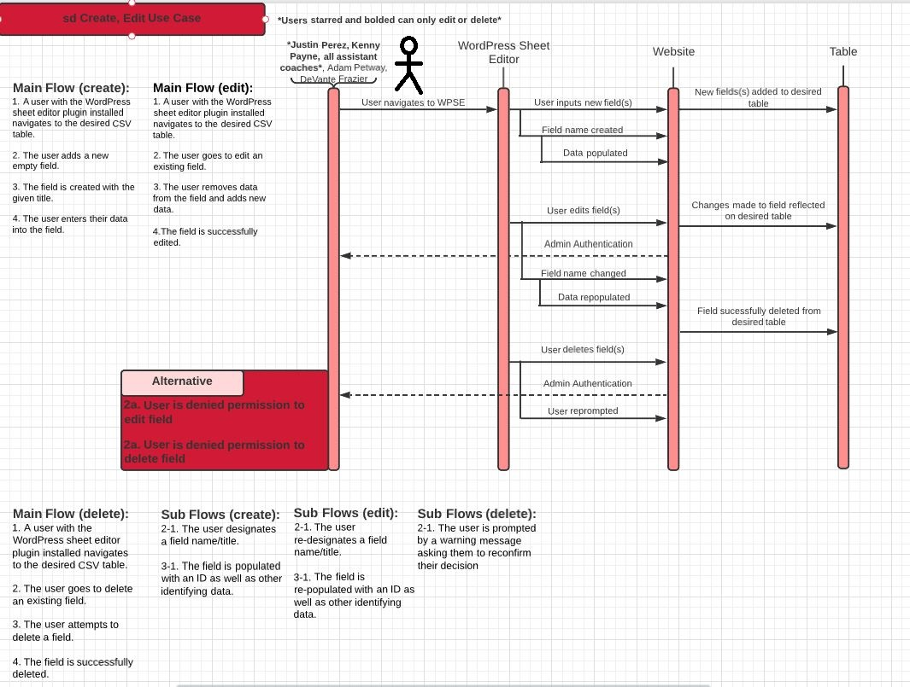

1. User or admin logs into the website

2. The user can create a field for any of the tables through the WordPress Sheet Editor

3. The user is forbidden from editing or deleting fields

4. The admin can create a field, edit a field, or delete a field on any of the tables

5. The changes are reflected in the table

**Use Case 13, 14, and 15 Diagram**

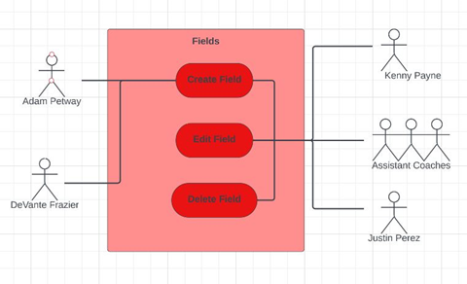

Narrative: Users (Coaches and Directors) can create fields, but only some coaches and directors who are admins can edit or delete fields.

**Use Case 16, 17, and 18 Descriptions**

|  |  |  |
| --- | --- | --- |
| Use Case Name: Create New Record | ID: 16 | Importance Level: High |
| Primary Actor: Employee | | Use Case Type: Detail, Essential |
| Stakeholders and Interests:  Justin Perez (director of men’s basketball administration) – can create new fields and name new fields.    Kenny Payne (head coach) – can create new fields and name new fields.    Danny Manning, Nolan Smith, and Josh Jamieson (assistant coaches) - can create new fields and name new fields.    Adam Petway (strength and conditioning coach) – can create new fields and name new fields.    DeVante Frazier (director of sports medicine/men’s basketball) – can create new fields and name new fields. | | |
| Brief Description: A user can define and create a new record within an existing table | | |
| Trigger: The user defines and adds a new record with the sheet editor plugin  Type: External | | |
| Relationships:  Association: Justin Perez, Kenny Payne, all assistant coaches, Adam Petway, DeVante Frazier  Include:  Extend: Edit record  Generalization: | | |
| Normal Flow of Events:   1. A user with the WordPress sheet editor plugin installed navigates to the desired CSV table. 2. The user goes to create a new record. 3. The user is asked to define the record by selecting which fields it will group together. 4. The record is created with the selected group of fields | | |
| Sub Flows:   * 1. The record is populated with an ID as well as other identifying data. | | |
| Alternate/Exceptional Flows: | | |

|  |  |  |
| --- | --- | --- |
| Use Case Name: Edit Record | ID: 17 | Importance Level: Low |
| Primary Actor: Administrator | | Use Case Type: Detail, Essential |
| Stakeholders and Interests:  Justin Perez (director of men’s basketball administration) – can edit records as an administrator.    Kenny Payne (head coach) – can edit records as an administrator.    Danny Manning, Nolan Smith, and Josh Jamieson (assistant coaches) - can edit records as an administrator. | | |
| Brief Description: A user can edit records within an existing table | | |
| Trigger: The user edits a record with the sheet editor plugin  Type: External | | |
| Relationships:  Association: Justin Perez, Kenny Payne, all assistant coaches  Include:  Extend:  Generalization: Create record | | |
| Normal Flow of Events:   1. A user with the WordPress sheet editor plugin installed navigates to the desired CSV table. 2. The user goes to edit an existing record. 3. The user is asked to re-define the record by selecting which fields it will group together. 4. The record is edited with the selected group of fields. | | |
| Sub Flows:   * 1. The record is re-populated with a new ID as well as other identifying data. | | |
| Alternate/Exceptional Flows:  2a. The user is denied permission to edit the record if they are not an admin | | |

|  |  |  |
| --- | --- | --- |
| Use Case Name: Delete Record | ID: 18 | Importance Level: Low |
| Primary Actor: Administrator | | Use Case Type: Detail, Essential |
| Stakeholders and Interests:  Administrator - wants to delete a record.  Website - tool used to collect record information | | |
| Brief Description: This use case will be able to delete a record only by an administrator. | | |
| Trigger: Administrator navigates to the home page on the website.  Type: External | | |
| Relationships:  Association: Administrator  Include:  Extend: Edit Record, Delete Record  Generalization: | | |
| Normal Flow of Events:   1. The administrator navigates to the home page on the website. 2. The administrator will be able to edit, delete, and add records. | | |
| SubFlows: None | | |
| Alternate/Exceptional Flows: None | | |

**Use Case 16 and 17 Sequence Diagram**

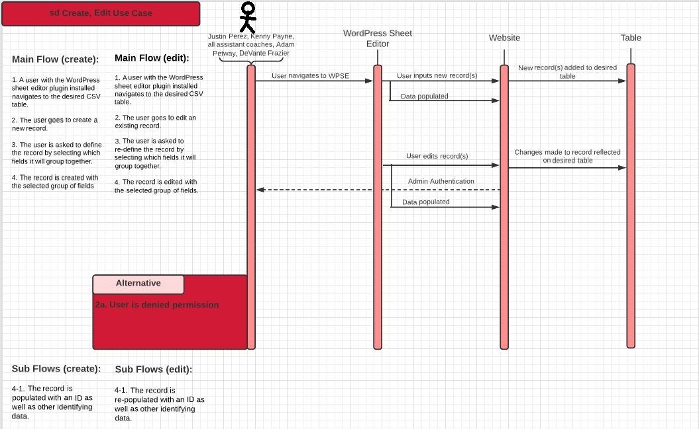

1. User or admin logs into the website

2. The user can create a record for any of the tables through the WordPress Sheet Editor

3. The user is forbidden from editing records

4. The admin can create a record or edit a record on any of the tables

5. The changes are reflected in the table

**Use Case 18 Sequence Diagram**

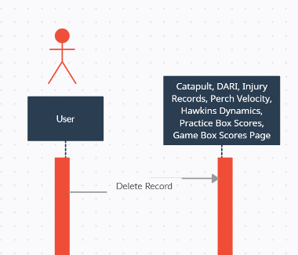

**Use Case 16, 17, and 18 Diagram**

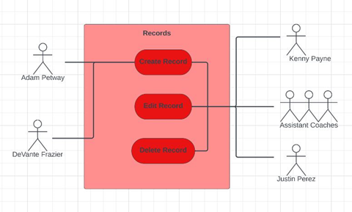

Narrative: Users (Coaches and Directors) can create fields, but only some coaches and directors who are admins can edit or delete fields.

**Use Case 19 Description**

|  |  |  |
| --- | --- | --- |
| Use Case Name: Create New Column | ID: 19 | Importance Level: Medium |
| Primary Actor: Head Coach | | Use Case Type: Detail, Essential |
| Stakeholders and Interests:  Head Coach - Coach may want to add their schedules.  Website - tool used to collect players information | | |
| Brief Description: This use case allows a new column to be inputted by a user within any table | | |
| Trigger: Head coach navigates to the home page on the website.  Type: External | | |
| Relationships:  Association: Head Coach  Include:  Extend:  Generalization: Create Donation | | |
| Normal Flow of Events:   1. The head coach navigates to the home page on the website. 2. The head coach can create new columns to add more information to the games. | | |
| SubFlows: None | | |
| Alternate/Exceptional Flows:  5a. The creation of the column was not processed. | | |

**Use Case 19 Sequence Diagram**

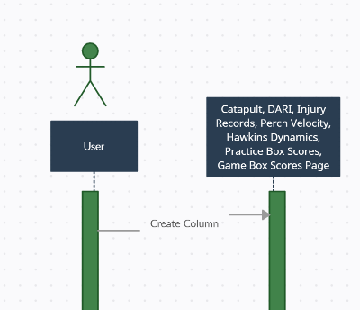

1. This use case is initiated when the user/admin decides to create a column to add information about the players on any of the pages above.
2. To perform this action, the user/admin would click the “Create New Column” button in the admin view window.

**Use Case 19 Diagram**

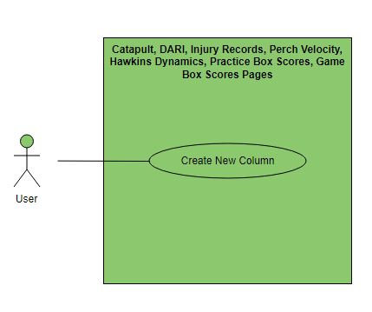

Narrative: The user/admin can create new columns.

**Use Case 20 Description**

|  |  |  |
| --- | --- | --- |
| Use Case Name: Edit Column Name | ID: 20 | Importance Level: Low |
| Primary Actor: Coach | | Use Case Type: Detail, Essential |
| Stakeholders and Interests:  Coach - coaches may want to edit their schedules.  Website - tool used to collect players information | | |
| Brief Description: This use case allows a column to be edited by a user within any table | | |
| Trigger: Coach navigates to the home page on the website.  Type: External | | |
| Relationships:  Association: Coach  Include:  Extend:  Generalization: Edit Column | | |
| Normal Flow of Events:   1. The coach navigates to the home page on the website. 2. The coach can edit the columns for the schedules for more information on the games. | | |
| SubFlows: None | | |
| Alternate/Exceptional Flows:  5a. The edit feature was not processed. | | |

**Use Case 20 Sequence Diagram**

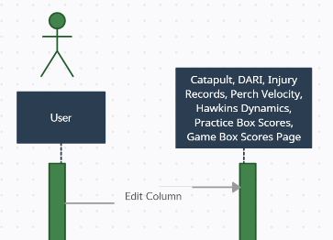

1. This use case is initiated when the user/admin decides to edit a column to add information about the players on any of the pages above.
2. To perform this action, the user/admin would click the “Edit Column” button in the admin view window.

**Use Case 20 Diagram**

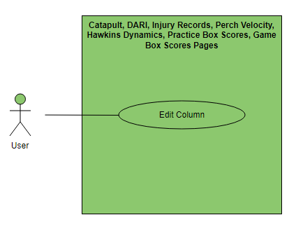

Narrative: The user/admin can edit the columns.

**Use Case 21 Description**

|  |  |  |
| --- | --- | --- |
| Use Case Name: Delete Column | ID: 21 | Importance Level: High |
| Primary Actor: Administrator | | Use Case Type: Detail, Essential |
| Stakeholders and Interests:  Administrator - Admin may want to delete their schedules.  Website - tool used to delete players information | | |
| Brief Description: This use case allows a column can only be deleted by an administrator. | | |
| Trigger: Admin navigates to the home page on the website.  Type: External | | |
| Relationships:  Association: Administrator  Include:  Extend:  Generalization: Delete Column | | |
| Normal Flow of Events:   1. The admin navigates to the home page on the website. 2. The admin can delete the columns on more information for the games. | | |
| SubFlows: None | | |
| Alternate/Exceptional Flows:  5a. The delete feature was not processed. | | |

**Use Case 21 Sequence Diagram**

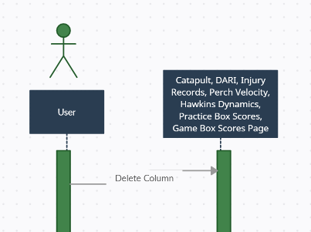

1. This use case is initiated when the user/admin decides to delete a column to add information about the players on any of the pages above.
2. To perform this action, the user/admin would click the “Delete Column” button in the admin view window.

**Use Case 21 Diagram**

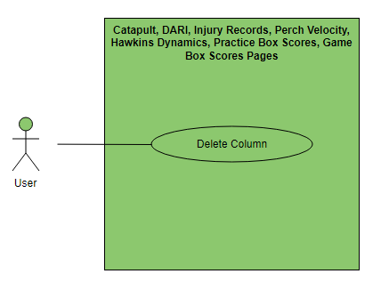

Narrative: The user/admin can delete columns.

**Use Case 22 Description**

|  |  |  |
| --- | --- | --- |
| Use Case Name: Create New Row | ID: 22 | Importance Level: Medium |
| Primary Actor: Head Coach | | Use Case Type: Detail, Essential |
| Stakeholders and Interests:  Head Coach - wants to create a new row for the table.  Website - tool used to collect adopter information | | |
| Brief Description: This use case allows a new row to be inputted by a user within any table | | |
| Trigger: Head coach navigates to the home page on the website.  Type: External | | |
| Relationships:  Association: Head Coach  Include:  Extend: Create Row  Generalization: | | |
| Normal Flow of Events:   1. The head coach navigates to the home page on the website. 2. The head coach can create the rows for schedules for more information on the games | | |
| SubFlows: | | |
| Alternate/Exceptional Flows:  6a. The create feature was not processed. | | |

**Use Case 22 Sequence Diagram**

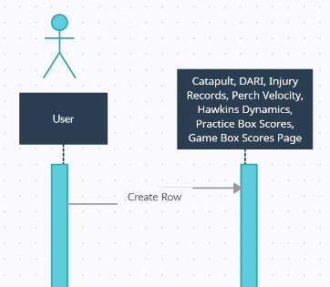

1. This use case is initiated when the user/admin decides to create a row to add information about the players on any of the pages above.
2. To perform this action, the user/admin would click the “Create New Row” button in the admin view window.

**Use Case 22 Diagram**

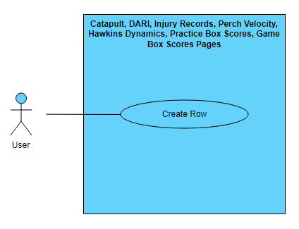

Narrative: The user/admin can create rows.

**Use Case 23 Description**

|  |  |  |
| --- | --- | --- |
| Use Case Name: Edit Row Name | ID: 23 | Importance Level: Low |
| Primary Actor: Coach | | Use Case Type: Detail, Essential |
| Stakeholders and Interests:  Coach - coaches may want to edit the rows.  Website - tool used to collect players information | | |
| Brief Description: This use case allows a row to be edited by a user within any table | | |
| Trigger: Coach navigates to the home page on the website.  Type: External | | |
| Relationships:  Association: Coach  Include:  Extend:  Generalization: Edit row | | |
| Normal Flow of Events:   1. The coach navigates to the home page on the website. 2. The coach can edit the rows for the schedules for more information on the games. | | |
| SubFlows: None | | |
| Alternate/Exceptional Flows:  5a. The edit feature was not processed. | | |

**Use Case 23 Sequence Diagram**

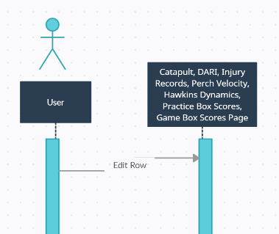

1. This use case is initiated when the user/admin decides to create a row to add information about the players on any of the pages above.
2. To perform this action, the user/admin would click the “Edit Row” button in the admin view window.

**Use Case 23 Diagram**

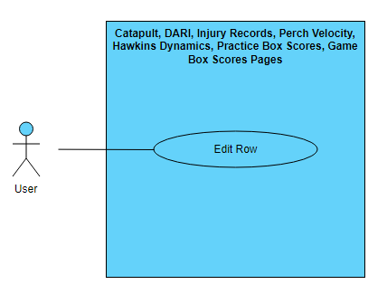

Narrative: The user/admin can edit rows.

**Use Case 24 Description**

|  |  |  |
| --- | --- | --- |
| Use Case Name: Delete Row | ID: 24 | Importance Level: High |
| Primary Actor: Administrator | | Use Case Type: Detail, Essential |
| Stakeholders and Interests:  Administrator - Admin may want to delete their schedules.  Website - tool used to delete players information | | |
| Brief Description: This use case allows a row can only be deleted by an administrator. | | |
| Trigger: Admin navigates to the home page on the website.  Type: External | | |
| Relationships:  Association: Administrator  Include:  Extend:  Generalization: Delete Row | | |
| Normal Flow of Events:   1. The admin navigates to the home page on the website. 2. The admin can delete the rows on more information for the games. | | |
| SubFlows: None | | |
| Alternate/Exceptional Flows:  5a. The delete feature was not processed. | | |

**Use Case 24 Sequence Diagram**

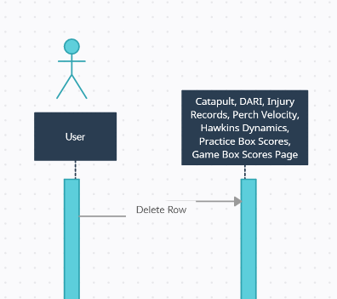

1. This use case is initiated when the user/admin decides to delete a row to add information about the players on any of the pages above.
2. To perform this action, the user/admin would click the “Delete Row” button in the admin view window.

**Use Case 24 Diagram**

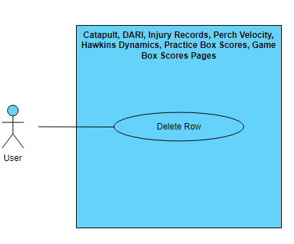

Narrative: The user/admin can delete rows.

**Use Case Descriptions 25, 26, 27, 28, and 29**

|  |  |  |
| --- | --- | --- |
| Use Case Name: Create Graph | ID: 25 | Importance Level: High |
| Primary Actor: | | Use Case Type: Data Analysis |
| Stakeholders and Interests:  User - User may want to create and edit a graph with the information gathered.  Website - tool used to collect information about NCAA basketball.  Perch Velocity – Tool used to create graphs. | | |
| Brief Description: This use case allows for the user to create a graph to help analyze information/data. | | |
| Trigger: User enters the Perch Velocity page and wants to create a graph  Type: External | | |
| Relationships:  Association: User  Include:  Extend:  Generalization: Create graph | | |
| Normal Flow of Events:   1. The user navigates to the “Perch” page on the website. 2. The user clicks on the “data entry” button in the page. 3. The user then adds the required data to the graph. 4. The user presses the “save graph” button. 5. The graph is added to the website in the “Perch” page. | | |
| SubFlows: | | |
| Alternate/Exceptional Flows:  1a. The “Perch” page pops up as an error.  4a. The graph does not save properly. | | |

|  |  |  |
| --- | --- | --- |
| Use Case Name: Edit graph data series | ID: 26 | Importance Level: low |
| Primary Actor: User | | Use Case Type: Data Analysis |
| Stakeholders and Interests:  User – User may want to edit a data series on a graph.  Website - Tool used to collect information about NCAA basketball.  Perch Velocity – Tool used to create graphs. | | |
| Brief Description: This use case allows for the user to edit a graph. | | |
| Trigger: User enters the Perch Velocity page and wants to edit a graph  Type: External | | |
| Relationships:  Association: User  Include:  Extend:  Generalization: Edit graph data series | | |
| Normal Flow of Events:   1. The user navigates to the “Perch” page on the website. 2. The user finds the graph that needs to be edited. 3. The user then triple clicks on the graph. 4. The graph will display edit options and the user clicks on what needs to be edited. 5. The user edits the necessary information. 6. The user presses the save “save edit” button. 7. The saved graph will now show on the website. | | |
| SubFlows: | | |
| Alternate/Exceptional Flows:  1a. The “Perch” page pops up as an error.  6a. The graph edit made did not save properly. | | |

|  |  |  |
| --- | --- | --- |
| Use Case Name: Delete Graph | ID: 27 | Importance Level: Low |
| Primary Actor: User | | Use Case Type: Detail |
| Stakeholders and Interests:  User – User may want to edit a data series on a graph.  Website - Tool used to collect information about NCAA basketball.  Perch Velocity – Tool used to create graphs. | | |
| Brief Description: This use case describes how graphs are deleted within Perch Velocity. | | |
| Trigger: User enters the Perch Velocity page and wants to delete a graph.  Type: External | | |
| Relationships:  Association: User  Include:  Extend:  Generalization: Edit Graph | | |
| Normal Flow of Events:   1. The user navigates to the “Perch” page on the website. 2. The user right clicks on the graph. 3. The user then presses the “delete” option. 4. A confirmation button will show up, the user presses “confirm”. 5. The graph will be deleted from the website. | | |
| SubFlows: | | |
| Alternate/Exceptional Flows:  1a. The “Perch” page pops up as an error.  5a. The graph did not delete from the page. | | |

|  |  |  |
| --- | --- | --- |
| Use Case Name: Search within table or graph | ID: 28 | Importance Level: High |
| Primary Actor: User | | Use Case Type: Detail |
| Stakeholders and Interests:  User – User may want to edit a data series on a graph.  Website - Tool used to collect information about NCAA basketball.  Perch Velocity – Tool used to create graphs. | | |
| Brief Description: This use case allows for the user to search data within a table or graph | | |
| Trigger: User enters the Perch Velocity page and clicks “Search”.  Type: External | | |
| Relationships:  Association: User  Include:  Extend:  Generalization: Search table or graph | | |
| Normal Flow of Events:   1. The user navigates to the “Perch” page on the website. 2. The user presses the search bar labeled “Search Player”. 3. The user presses the enter key on the keyboard. 4. The website will then display a graph for that player. | | |
| SubFlows: | | |
| Alternate/Exceptional Flows:  1a. The “Perch” page pops up as an error.  3a. The player searched could not be found.  4a. A graph does not display for the player. | | |

|  |  |  |
| --- | --- | --- |
| Use Case Name: Apply functions to graph or table | ID: 29 | Importance Level: High |
| Primary Actor: User | | Use Case Type: Data Analysis, Detail |
| Stakeholders and Interests:  User – User may want to edit a data series on a graph.  Website - Tool used to collect information about NCAA basketball.  Perch Velocity – Tool used to create graphs. | | |
| Brief Description: This use case allows for the user to apply a function to a table or graph within Perch Velocity. | | |
| Trigger: User enters the Perch Velocity page and wants to apply a function to a graph.  Type: Internal | | |
| Relationships:  Association: User  Include:  Extend:  Generalization: Apply a function | | |
| Normal Flow of Events:   1. The user navigates to the “Perch” page on the website. 2. The user right clicks on the table. 3. The user selects what function to apply. 4. The user presses enter. 5. The chart updates according to the function. | | |
| SubFlows: | | |
| Alternate/Exceptional Flows:  1a. The link on the website does not take the user to the “Perch” page.  5a. The function does not get applied properly | | |

**Use Case Diagram 24, 25, 26, 27, 28, and 29:**

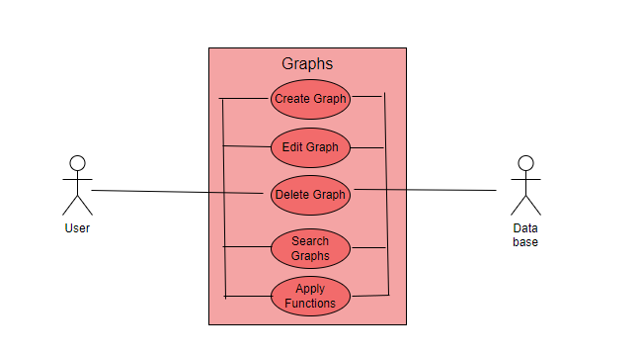

Narrative: The user creates, edits, deletes, searches, or applies a function and updates the datadase.

**Use Case 24, 25, 26, 27, 28, and 29 Sequence Diagram:**

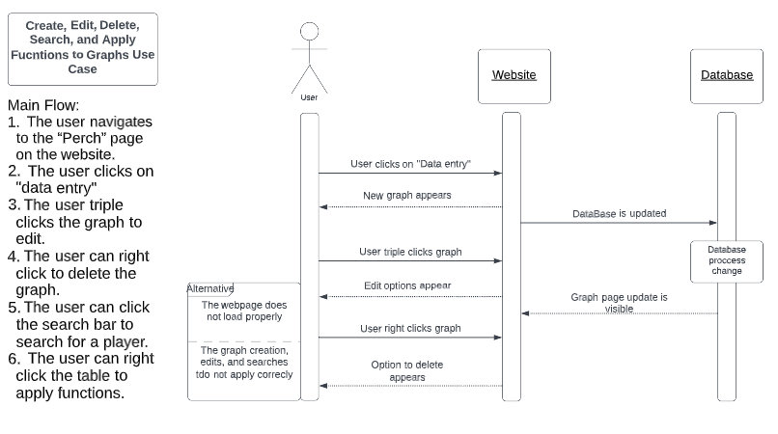

# 1. This use case is initiated when the user wants to create, edit, delete, search, or apply functions to the data

# 2. To do this the user would click on data entry and import the data, and right click to delete it, and click the search bar to search and add functions.

**Use Case 30 Description:**

|  |  |  |
| --- | --- | --- |
| Use Case Name: Link “Synergy” Data | ID: 30 | Importance Level: High |
| Primary Actor: User | | Use Case Type: Detail, Essential |
| Stakeholders and Interests:  User – User may want to access the synergy website.  Website - Tool used to collect information about NCAA basketball.  Synergy – Tool used to help coaching and team play. | | |
| Brief Description: This use case will link the Synergy website to the private Louisville basketball website | | |
| Trigger: User navigates to the Synergy page on the website.  Type: External | | |
| Relationships:  Association: User  Include:  Extend:  Generalization: Link the Synergy Website | | |
| Normal Flow of Events:   1. The user navigates to the “Synergy” page on the website. 2. The user is now on the Synergy page. 3. The user can navigate the page. | | |
| SubFlows: | | |
| Alternate/Exceptional Flows:  1a. The link on the website does not take the user to the “Synergy” page. | | |

**Use Case Diagram:**

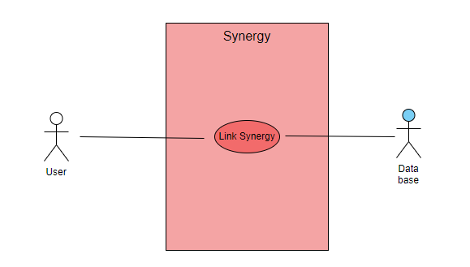

Narrative: The user clicks on the Synergy link.

**Sequence Diagram:**

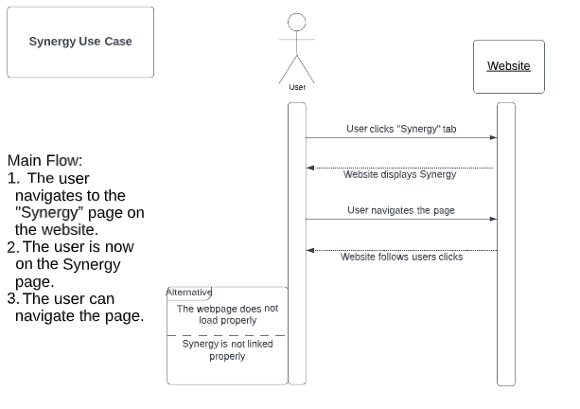

1. This use case is initiated when the user wants to use the synergy tab
2. To do this the user would click the synergy tab from the home screen and would be sent to the website

**Use Case 31 Description:**

|  |  |  |
| --- | --- | --- |
| Use Case Name: Link SmarterBase | ID: 31 | Importance Level: High |
| Primary Actor: User | | Use Case Type: Detail, Essential |
| Stakeholders and Interests:  User – User may want to access the SmarterBase website.  Website - Tool used to collect information about NCAA basketball.  SmarterBase– Used to help session planning and injury management. | | |
| Brief Description: This use case allows SmarterBase Data to be accessible in the private UofL basketball website. | | |
| Trigger: User clicks on the “SmarterBase” tab.  Type: Internal | | |
| Relationships:  Association: User  Include:  Extend:  Generalization: Link SmarterBase | | |
| Normal Flow of Events:   1. The user navigates to the “SmarterBase” page on the website. 2. The user is now on the SmarterBase page. 3. The user can navigate the page. | | |
| SubFlows: | | |
| Alternate/Exceptional Flows:  1a. The link on the website does not take the user to the “SmarterBase” page. | | |

**Use Case 31 Diagram:**

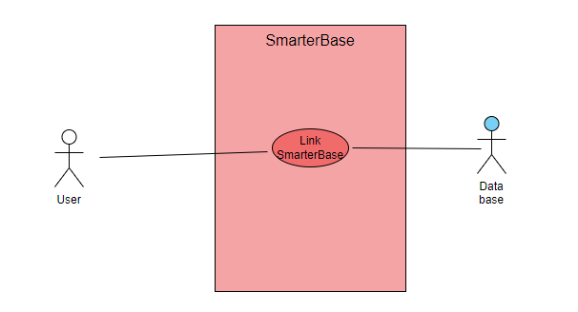

**Narrative:** The user clicks on the SmarterBase link.

**Use Case 31 Sequence Diagram:**

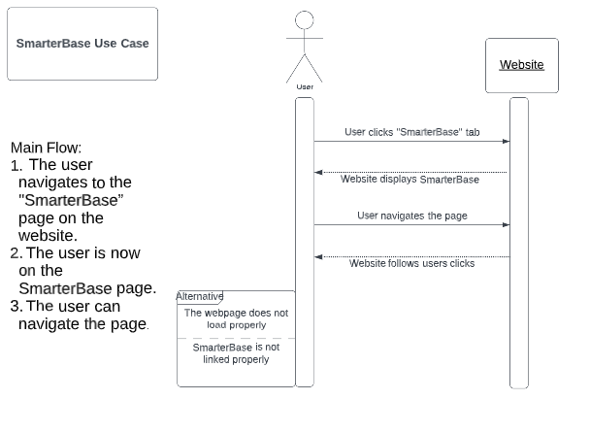

1. This use case is initiated when the user wants to use SmarterBase
2. To do this the user would click the SmarterBase tab from the homepage

**Use Case 32 Description:**

|  |  |  |
| --- | --- | --- |
| Use Case Name: Input Data with KenPom | ID: 32 | Importance Level: High |
| Primary Actor: User | | Use Case Type: Detail, Essential |
| Stakeholders and Interests:  User – User may want to access the KenPom Data.  Website - Tool used to collect information about NCAA basketball.  KenPom – Tool used for analytics. | | |
| Brief Description: This use case describes how data is inputted with KenPom. | | |
| Trigger: User presses the “KenPom” tab on the website.  Type: Internal | | |
| Relationships:  Association: User  Include:  Extend:  Generalization: Input Data with KenPom | | |
| Normal Flow of Events:   1. The user navigates to the “KenPom” page on the website. 2. The user right clicks on the existing data. 3. The user selects “add data”. 4. The user finds the data they want to add and selects it. 5. The data is added to the existing data | | |
| SubFlows: | | |
| Alternate/Exceptional Flows:  1a. The link on the website does not take the user to the “KenPom” page.  5a. The data added did not save properly. | | |

|  |  |  |
| --- | --- | --- |
| Use Case Name: Edit Data with KenPom | ID: 33 | Importance Level: High |
| Primary Actor: User | | Use Case Type: Detail, Essential |
| Stakeholders and Interests:  User – User may want to access the KenPom Data.  Website - Tool used to collect information about NCAA basketball.  KenPom – Tool used for analytics | | |
| Brief Description: This use case describes how a user can edit data in the KenPom tab. | | |
| Trigger: User clicks on the “KenPom” tab on the website.  Type: Internal | | |
| Relationships:  Association: User  Include:  Extend:  Generalization: Edit Data with KenPom | | |
| Normal Flow of Events:   1. The user navigates to the “KenPom” page on the website. 2. The user triple clicks on the data they want to edit. 3. The user manually inputs the correct data. 4. A confirmation message appears. 5. The user clicks the “confirm” button. 6. The data is updated on the website. | | |
| SubFlows: | | |
| Alternate/Exceptional Flows:  1a. The link on the website does not take the user to the “SmarterBase” page.  6a. The data did not get edited properly. | | |

**Use Case 32 Diagram:**

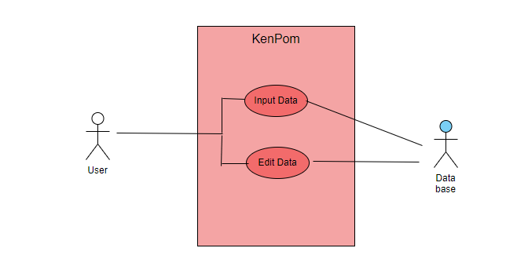

**Narrative:** The user inputs or edits data with KenPom and updates the database.

**Use Case 32 Sequence Diagram:**

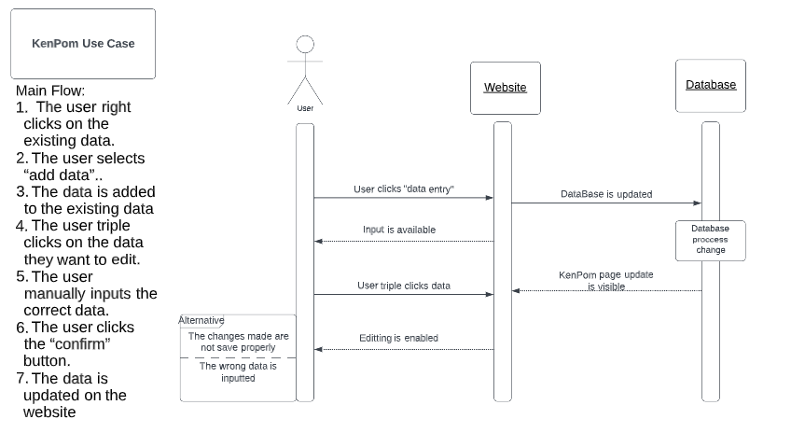  
**1.** This use case is initiated when the user wants to import or edit KenPom data

**2.** To do this the user would click add data and then triple click the data that needs to be edited.

**Use Case Descriptions 34-41**

**Sequence Diagrams 34-41**

**Use Case 34 and 35 diagram**

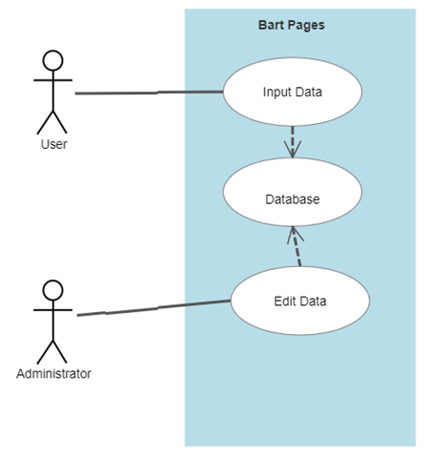

Narrative: User will input data into the database but only coaches who are admins can edit the data.

**Use Case 36 and 37 diagram**

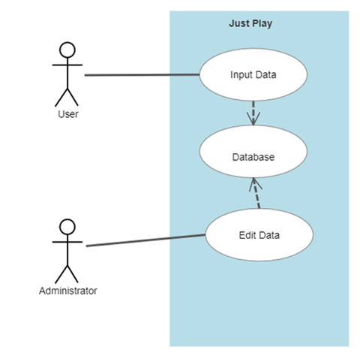

Narrative: User will input data into the database but only coaches who are admins can edit the data.

**Use Case 38 and 39 diagram**

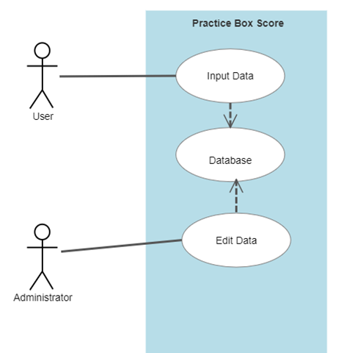

Narrative: User or coaches will input data into the database but only coaches who are admins can edit the data.

**Use Case 40 and 41 diagram**

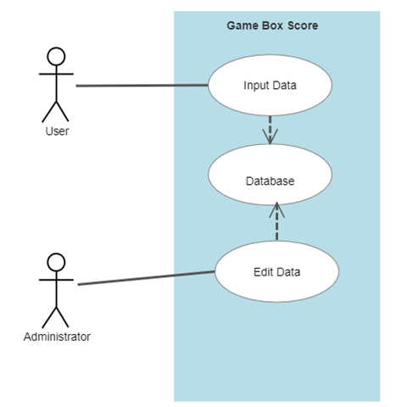

Narrative: User or coaches will input data into the database but only coaches who are admins can edit the data.

**Trace Matrix**

<https://docs.google.com/spreadsheets/d/e/2PACX-1vT68DuAXSHUyLdNYKZJ5OY3VAQH9kM9oFPG9oIm-T8bVufosU9fvpzWRStdxB0cdCq47EhYe44HJSbY/pubhtml>

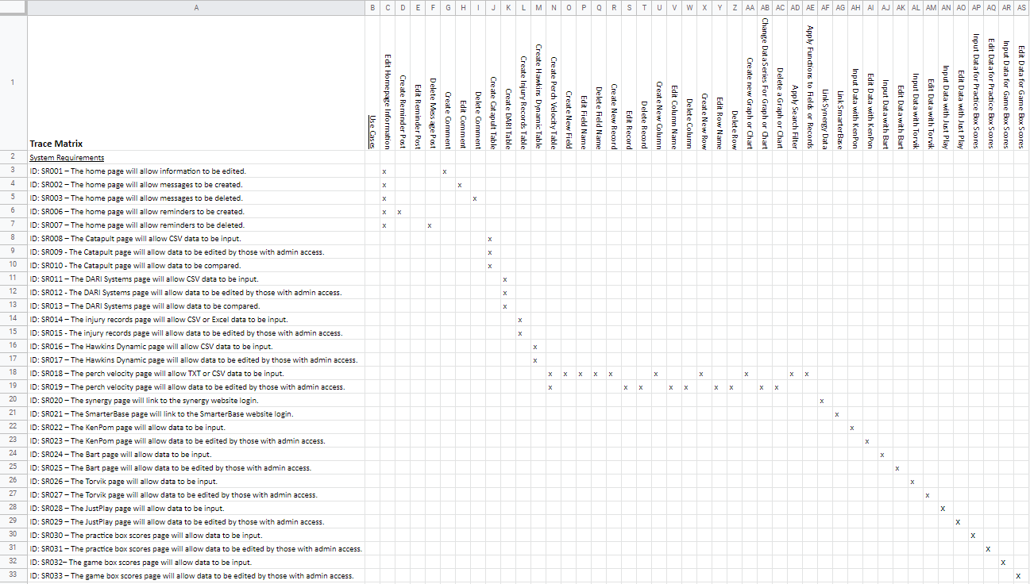

**Class Diagram**

Our class diagram showcases the relationships between use-case entities using verb-noun structure where verbs are methods/functions and nouns are attributes. Attributes are displayed with public and foreign key denotations as well as the access level (public, private, etc.) of each attribute. Relationships are color coded based on which entities they are associated with. This was done to reduce confusion in the intersection of relationships on the diagram. A color-coding guide is provided in the top left corner of the diagram. The administrator and user are the primary entities in this diagram and they each have their own subclasses connected to them. The administrator’s duties are listed as the class methods. They can create, edit, and delete website pages, tables, reminder posts, comments, and more from the website. They are able to link data from outside resources such as Synergy and SmarterBase. The user possesses the same abilities as the admin, minus the abilities to edit or delete any kind of content. Some website users are restricted from accessing data that they do not require access to. For example, the sports medicine director does not require access to other tables and forms outside of injury records.

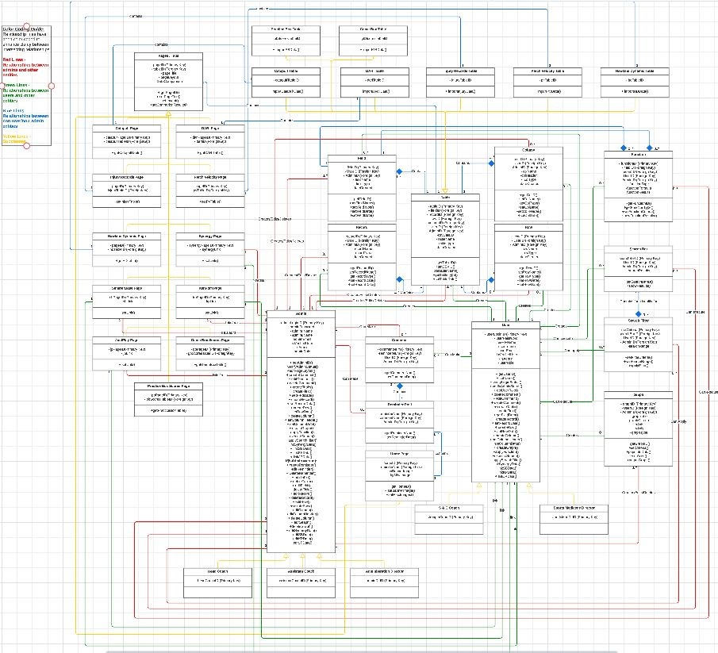As it is a bit indiscernible to read in the document, a link is provided to the diagram below:

[Class Diagram on LucidChart](https://lucid.app/lucidchart/e58e74fb-d946-4aad-9a6f-b0ac67e5fbf4/edit?view_items=CzrQ-6~OrasJ&invitationId=inv_6e955e0c-9ce9-4001-bf42-1962b7ff7be2)

**Database Diagram**

Our database design diagram is a visual representation of the overall structure of our design. Similarly, to our class diagram it shows the relationships between each class and how they relate to each other. The database design diagram focuses more on how the attributes, including primary and foreign keys, are formatted. For example, we have determined some attributes to be integers, strings, unsigned longs, etc. This information will be vital when the development of the project begins. It will help the development team organize and allow them to work in a more efficient manner.

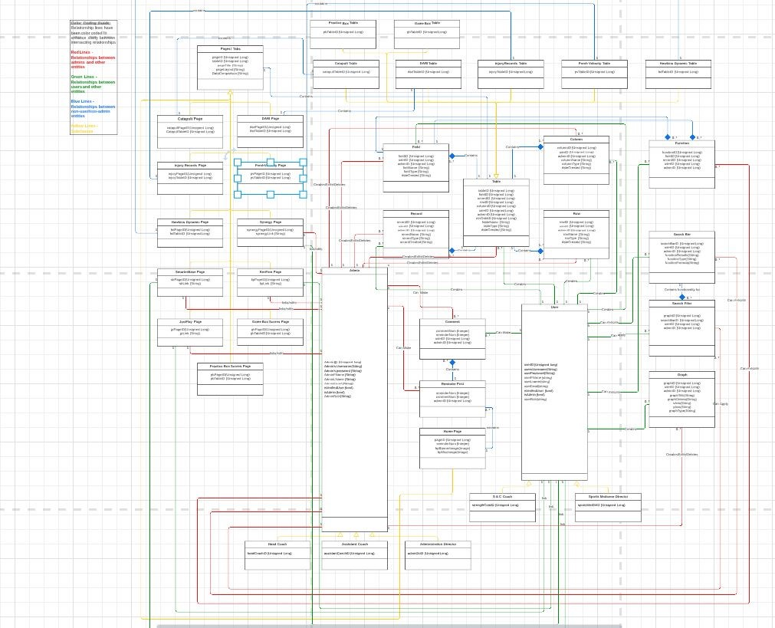As it is a bit indiscernible to read in the document, a link is provided to the diagram below:

[Databse Diagram on LucidChart](https://lucid.app/lucidchart/b63cd893-0ffe-4842-b8d6-2b9f6cdc8272/edit?view_items=HcLQf41E2.2Z&invitationId=inv_62af6ab9-e7cb-4121-a652-071f7d7f0f79)

**Database Definitions**

**Web Page**

|  |  |  |  |  |
| --- | --- | --- | --- | --- |
| Attribute | Attribute Definition | Attribute Type | Attribute Size | Key |
| Page ID | Unique identifier for the page | Unsigned long | 4 bytes | Primary |
| Table ID | Unique identifier for the table associated with a page | Unsigned Long | 4 bytes | Foreign |
| Page Title | Unique identifier for the title of the page | String | 255 bytes max | No |
| Page Layout | Describes the layout of the page | String | 255 bytes max | No |
| Data Comparison | Shows the results of data comparison between two or more data points | String | 255 bytes max | Np |

**Home Page**

|  |  |  |  |  |
| --- | --- | --- | --- | --- |
| Attribute | Attribute Definition | Attribute Type | Attribute Size | Key |
| HomeID | Unique identifier for the page | Unsigned long | 4 bytes | Primary |
| ReminderNum | Unique identifier for the reminder | Unsigned long | 4 bytes | Foreign |

**Reminder**

|  |  |  |  |  |
| --- | --- | --- | --- | --- |
| Attribute | Attribute Definition | Attribute Type | Attribute Size | Key |
| ReminderNum | Unique identifier for the reminder | Unsigned long | 4 bytes | Primary |
| CommentNum | Unique identifier for the comment | Unsigned long | 4 bytes | Foreign |
| AdminID | Unique identifier for the user | Unsigned long | 4 bytes | Foreign |

**Comment**

|  |  |  |  |  |
| --- | --- | --- | --- | --- |
| Attribute | Attribute Definition | Attribute Type | Attribute Size | Key |
| CommentNum | Unique identifier for the comment | Unsigned long | 4 bytes | Primary |
| ReminderNum | Unique identifier for the reminder | Unsigned long | 4 bytes | Foreign |
| AdminID | Unique identifier for the user | Unsigned long | 4 bytes | Foreign |

**Catapult Page**

|  |  |  |  |  |
| --- | --- | --- | --- | --- |
| Attribute | Attribute Definition | Attribute Type | Attribute Size | Key |
| Catapult Page ID | Unique identifier for the page | Unsigned long | 4 bytes | Primary |
| Catapult Table ID | Unique identifier for the CSV table data input by user or admin | Unsigned long | 4 bytes | Foreign |

**DARI Page**

|  |  |  |  |  |
| --- | --- | --- | --- | --- |
| Attribute | Attribute Definition | Attribute Type | Attribute Size | Key |
| Catapult Page ID | Unique identifier for the page | Unsigned long | 4 bytes | Primary |
| Catapult Table ID | Unique identifier for the CSV table data input by user or admin | Unsigned long | 4 bytes | Foreign |

**Injury Records Page**

|  |  |  |  |  |
| --- | --- | --- | --- | --- |
| Attribute | Attribute Definition | Attribute Type | Attribute Size | Key |
| Records Page ID | Unique identifier for the page | Unsigned long | 4 bytes | Primary |
| Records Table ID | Unique identifier for the CSV table data input by user or admin | Unsigned long | 4 bytes | Foreign |

**Hawkins Dynamic Page**

|  |  |  |  |  |
| --- | --- | --- | --- | --- |
| Attribute | Attribute Definition | Attribute Type | Attribute Size | Key |
| HD Page ID | Unique identifier for the page | Unsigned long | 4 bytes | Primary |
| HD Table ID | Unique identifier for the CSV table data input by user or admin | Unsigned long | 4 bytes | Foreign |

**Perch Velocity Page**

|  |  |  |  |  |
| --- | --- | --- | --- | --- |
| Attribute | Attribute Definition | Attribute Type | Attribute Size | Key |
| PV Page ID | Unique identifier for the page | Unsigned long | 4 bytes | Primary |
| PV Table ID | Unique identifier for the CSV table data input by user or admin | Unsigned long | 4 bytes | Foreign |

**Table**

|  |  |  |  |  |
| --- | --- | --- | --- | --- |
| Attribute | Attribute Definition | Attribute Type | Attribute Size | Key |
| Table ID | Unique identifier for the table | Unsigned Long | 4 bytes | Primary |
| Field ID | Unique identifier for the fields contained within the table | Unsigned Long | 4 bytes | Foreign |
| Record ID | Unique identifier for the records contained within the table | Unsigned Long | 4 bytes | Foreign |
| Row ID | Unique identifier for the rows contained within the table | Unsigned Long | 4 bytes | Foreign |
| Column ID | Unique identifier for the columns contained within the table | Unsigned Long | 4 bytes | Foreign |
| CSV Data ID | Unique identifier for the CSV table data input by user or admin | Unsigned Long | 4 bytes | No |
| Table Name | Unique identifier for the name of the table | String | 255 bytes max | No |
| Table Type | Unique identifier that shows which subtype the table is | String | 255 bytes max | No |
| Date Created | Unique identifier for the date the table was created | String | 255 bytes max | No |

**Catapult Table**

|  |  |  |  |  |
| --- | --- | --- | --- | --- |
| Attribute | Attribute Definition | Attribute Type | Attribute Size | Key |
| Catapult Table ID | Unique identifier for the table | Unsigned long | 4 bytes | Primary |

**DARI Table**

|  |  |  |  |  |
| --- | --- | --- | --- | --- |
| Attribute | Attribute Definition | Attribute Type | Attribute Size | Key |
| DARI Table ID | Unique identifier for the table | Unsigned long | 4 bytes | Primary |

**Injury Records Table**

|  |  |  |  |  |
| --- | --- | --- | --- | --- |
| Attribute | Attribute Definition | Attribute Type | Attribute Size | Key |
| Injury Table ID | Unique identifier for the table | Unsigned long | 4 bytes | Primary |

**Perch Velocity Records Table**

|  |  |  |  |  |
| --- | --- | --- | --- | --- |
| Attribute | Attribute Definition | Attribute Type | Attribute Size | Key |
| PV Table ID | Unique identifier for the table | Unsigned long | 4 bytes | Primary |

**Hawkins Dynamic Table**

|  |  |  |  |  |
| --- | --- | --- | --- | --- |
| Attribute | Attribute Definition | Attribute Type | Attribute Size | Key |
| HD Table ID | Unique identifier for the table | Unsigned long | 4 bytes | Primary |

**Practice Box Scores Table**

|  |  |  |  |  |
| --- | --- | --- | --- | --- |
| Attribute | Attribute Definition | Attribute Type | Attribute Size | Key |
| PB Table ID | Unique identifier for the table | Unsigned long | 4 bytes | Primary |

**Game Box Scores Table**

|  |  |  |  |  |
| --- | --- | --- | --- | --- |
| Attribute | Attribute Definition | Attribute Type | Attribute Size | Key |
| GB Table ID | Unique identifier for the table | Unsigned long | 4 bytes | Primary |

**Field**

|  |  |  |  |  |
| --- | --- | --- | --- | --- |
| Attribute | Attribute Definition | Attribute Type | Attribute Size | Key |
| Field ID | Unique identifier for the fields contained within a table | Unsigned Long | 4 bytes | Primary |
| Table ID | Unique identifier for the table the field(s) is contained within | Unsigned Long | 4 bytes | Foreign |
| User ID | Unique identifier for the use who creates the field | Unsigned Long | 4 bytes | Foreign |
| Admin ID | Unique identifier for the admin who creates, edits, or deletes the field | Unsigned Long | 4 bytes | Foreign |
| Field Name | Unique identifier for the name of the field | Unsigned Long | 4 bytes | No |
| Field Type | Unique identifier for the type(s) of data contained within a field(s) | String | 255 bytes max | No |
| Date Created | Unique identifier for the date the field was created | String | 255 bytes max | No |

**Record**

|  |  |  |  |  |
| --- | --- | --- | --- | --- |
| Attribute | Attribute Definition | Attribute Type | Attribute Size | Key |
| Record ID | Unique identifier for the records contained within a table | Unsigned Long | 4 bytes | Primary |
| Table ID | Unique identifier for the table the record(s) is contained within | Unsigned Long | 4 bytes | Foreign |
| User ID | Unique identifier for the use who creates the record | Unsigned Long | 4 bytes | Foreign |
| Admin ID | Unique identifier for the admin who creates, edits, or deletes the record | Unsigned Long | 4 bytes | Foreign |
| Record Name | Unique identifier for the name of the record | Unsigned Long | 4 bytes | No |
| Record Type | Unique identifier for the type(s) of data contained within a record(s) | String | 255 bytes max | No |
| Date Created | Unique identifier for the date the record was created | String | 255 bytes max | No |

**Row**

|  |  |  |  |  |
| --- | --- | --- | --- | --- |
| Attribute | Attribute Definition | Attribute Type | Attribute Size | Key |
| Row ID | Unique identifier for the rows contained within a table | Unsigned Long | 4 bytes | Primary |
| Table ID | Unique identifier for the table the row(s) are contained within | Unsigned Long | 4 bytes | Foreign |
| User ID | Unique identifier for the use who creates the row | Unsigned Long | 4 bytes | Foreign |
| Admin ID | Unique identifier for the admin who creates, edits, or deletes the row | Unsigned Long | 4 bytes | Foreign |
| Row Name | Unique identifier for the name of the row | Unsigned Long | 4 bytes | No |
| Row Type | Unique identifier for the type(s) of data contained within a row(s) | String | 255 bytes max | No |
| Date Created | Unique identifier for the date the row was created | String | 255 bytes max | No |

**Column**

|  |  |  |  |  |
| --- | --- | --- | --- | --- |
| Attribute | Attribute Definition | Attribute Type | Attribute Size | Key |
| Column ID | Unique identifier for the columns contained within a table | Unsigned Long | 4 bytes | Primary |
| Table ID | Unique identifier for the table the column(s) are contained within | Unsigned Long | 4 bytes | Foreign |
| User ID | Unique identifier for the use who creates the column | Unsigned Long | 4 bytes | Foreign |
| Admin ID | Unique identifier for the admin who creates, edits, or deletes the column | Unsigned Long | 4 bytes | Foreign |
| Column Name | Unique identifier for the name of the column | Unsigned Long | 4 bytes | No |
| Column Type | Unique identifier for the type(s) of data contained within a column(s) | String | 255 bytes max | No |
| Date Created | Unique identifier for the date the column was created | String | 255 bytes max | No |

**Administrator**

|  |  |  |  |  |
| --- | --- | --- | --- | --- |
| Attribute | Attribute Definition | Attribute Type | Attribute Size | Key |
| Admin ID | Unique identifier for the employee | Unsigned long | 4 bytes | Primary |
| Username | Admin’s username | String | 255 bytes max | No |
| Password | Admin’s password | String | 255 bytes max | No |
| FName | Admin’s first name | String | 255 bytes max | No |
| LName | Admin’s last name | String | 255 bytes max | No |
| Admin Email | Admin’s email address | String | 255 bytes max | No |
| isVerifiedUser | Checks login credentials | Bool | 1 byte | No |
| isAdmin | Checks to see if a user is an admin | Bool | 1 byte | No |
| Admin Role | What role does the admin have | String | 255 bytes max | No |

**Head Coach Admin**

|  |  |  |  |  |
| --- | --- | --- | --- | --- |
| Attribute | Attribute Definition | Attribute Type | Attribute Size | Key |
| Head Coach ID | Unique identifier for the head coach | Unsigned long | 4 bytes | Primary |

**Assistant Coach Admin**

|  |  |  |  |  |
| --- | --- | --- | --- | --- |
| Attribute | Attribute Definition | Attribute Type | Attribute Size | Key |
| Assistant Coach ID | Unique identifier for the assistant coach | Unsigned long | 4 bytes | Primary |

**Administration Director Admin**

|  |  |  |  |  |
| --- | --- | --- | --- | --- |
| Attribute | Attribute Definition | Attribute Type | Attribute Size | Key |
| AdminDir ID | Unique identifier for the administration director | Unsigned long | 4 bytes | Primary |

**User**

|  |  |  |  |  |
| --- | --- | --- | --- | --- |
| Attribute | Attribute Definition | Attribute Type | Attribute Size | Key |
| User ID | Unique identifier for the user | Unsigned long | 4 bytes | Primary |
| Username | User’s username | String | 255 bytes max | No |
| Password | User’s password | String | 255 bytes max | No |
| FName | User’s first name | String | 255 bytes max | No |
| LName | User’s last name | String | 255 bytes max | No |
| Admin Email | User’s email address | String | 255 bytes max | No |
| isVerifiedUser | Checks login credentials | Bool | 1 byte | No |
| isAdmin | Checks to see if a user is an admin | Bool | 1 byte | No |
| User Role | What role does the user have | String | 255 bytes max | No |

**Sport’s Medicene User**

|  |  |  |  |  |
| --- | --- | --- | --- | --- |
| Attribute | Attribute Definition | Attribute Type | Attribute Size | Key |
| SportsMedDir ID | Unique identifier for the sport’s medicene director user | Unsigned long | 4 bytes | Primary |

**Strength & Conditioning Coach User**

|  |  |  |  |  |
| --- | --- | --- | --- | --- |
| Attribute | Attribute Definition | Attribute Type | Attribute Size | Key |
| strengthCond ID | Unique identifier for the S&C coach user | Unsigned long | 4 bytes | Primary |

**Perch Velocity Page**

|  |  |  |  |  |
| --- | --- | --- | --- | --- |
| Attribute | Attribute Definition | Attribute Type | Attribute Size | Key |
| PV Page ID | Unique identifier for the perch velocity page | Unsigned long | 4 bytes | Primary |
| PV Table ID | Unique identifier for link associated with the PV data | Unsigned long | 4 bytes | Foreign |

**Synergy Page**

|  |  |  |  |  |
| --- | --- | --- | --- | --- |
| Attribute | Attribute Definition | Attribute Type | Attribute Size | Key |
| Synergy Page ID | Unique identifier for the Synergy page | Unsigned long | 4 bytes | Primary |
| Synergy Table ID | Unique identifier for link associated with the Synergy data | Unsigned long | 4 bytes | Foreign |

**SmarterBase Page**

|  |  |  |  |  |
| --- | --- | --- | --- | --- |
| Attribute | Attribute Definition | Attribute Type | Attribute Size | Key |
| SB Page ID | Unique identifier for the SB page | Unsigned long | 4 bytes | Primary |
| SB Table ID | Unique identifier for link associated with the SB data | Unsigned long | 4 bytes | Foreign |

**KenPom Page**

|  |  |  |  |  |
| --- | --- | --- | --- | --- |
| Attribute | Attribute Definition | Attribute Type | Attribute Size | Key |
| KP Page ID | Unique identifier for the KenPom page | Unsigned long | 4 bytes | Primary |
| KP Table ID | Unique identifier for link associated with the KenPom data | Unsigned long | 4 bytes | Foreign |

**JustPlay Page**

|  |  |  |  |  |
| --- | --- | --- | --- | --- |
| Attribute | Attribute Definition | Attribute Type | Attribute Size | Key |
| JP Page ID | Unique identifier for the JustPlay page | Unsigned long | 4 bytes | Primary |
| JP Table ID | Unique identifier for link associated with the JP data | Unsigned long | 4 bytes | Foreign |

**Practice Box Scores Page**

|  |  |  |  |  |
| --- | --- | --- | --- | --- |
| Attribute | Attribute Definition | Attribute Type | Attribute Size | Key |
| PB Page ID | Unique identifier for the page | Unsigned long | 4 bytes | Primary |
| PB Table ID | Unique identifier for the CSV table data input by user or admin | Unsigned long | 4 bytes | Foreign |

**Game Box Scores Page**

|  |  |  |  |  |
| --- | --- | --- | --- | --- |
| Attribute | Attribute Definition | Attribute Type | Attribute Size | Key |
| GB Page ID | Unique identifier for the page | Unsigned long | 4 bytes | Primary |
| GB Table ID | Unique identifier for the CSV table data input by user or admin | Unsigned long | 4 bytes | Foreign |

**Functions**

|  |  |  |  |  |
| --- | --- | --- | --- | --- |
| Attribute | Attribute Definition | Attribute Type | Attribute Size | Key |
| Function ID | Unique identifier for the page | Unsigned long | 4 bytes | Primary |
| Field ID | Unique identifier for the CSV table data input by user or admin | Unsigned long | 4 bytes | Foreign |
| Record ID | Identifier for the specific record that is being used | Unsigned long | 4 bytes | Foreign |
| User ID | Unique identifier for the user | Unsigned long | 4 bytes | Foreign |
| Admin ID | Unique identifier for the admin | Unsigned long | 4 bytes | Foreign |

**Search Bar**

|  |  |  |  |  |
| --- | --- | --- | --- | --- |
| Attribute | Attribute Definition | Attribute Type | Attribute Size | Key |
| Search Bar ID | Unique identifier for the search bar being used | Unsigned long | 4 bytes | Primary |
| User ID | Unique identifier for the user | Unsigned long | 4 bytes | Foreign |
| Admin ID | Unique identifier for the admin | Unsigned long | 4 bytes | Foreign |
| Function Results | The return of a function | String | 255 bytes max | No |
| Function Type | A certain search using a function | String | 255 bytes max | No |
| Function Formula | A series of traits in a function | String | 255 bytes max | No |

**Search Filter**

|  |  |  |  |  |
| --- | --- | --- | --- | --- |
| Attribute | Attribute Definition | Attribute Type | Attribute Size | Key |
| Graph ID | Unique identifier for a graph | Unsigned long | 4 bytes | Primary |
| Search Bar ID | Unique identifier for the search bar | Unsigned long | 4 bytes | Foreign |
| User ID | Unique identifier for the user | Unsigned long | 4 bytes | Foreign |
| Admin ID | Unique identifier for the admin | Unsigned long | 4 bytes | Foreign |

**Graph**

|  |  |  |  |  |
| --- | --- | --- | --- | --- |
| Attribute | Attribute Definition | Attribute Type | Attribute Size | Key |
| Graph ID | Unique identifier for the graph | Unsigned long | 4 bytes | Primary |
| User ID | Unique identifier for the user | Unsigned long | 4 bytes | Foreign |
| Admin ID | Unique identifier for the admin | Unsigned long | 4 bytes | Foreign |
| Graph Title | Unique title for a graph | String | 255 bytes max | No |
| Graph Criteria | The attributes included in a graph | String | 255 bytes max | No |
| X Axis | The name of the x axis in a graph | String | 255 bytes max | No |
| Y Axis | The name of the y axis in a graph | String | 255 bytes max | No |
| Graph Type | The type of graph that is being used | String | 255 bytes max | No |

**User Interface Navigation Diagram and Screen Layouts**

The user interface navigation diagram is a visual representation that shows the flow a user will go through to find the information they are looking for as well as how the different interact when they are clicked.

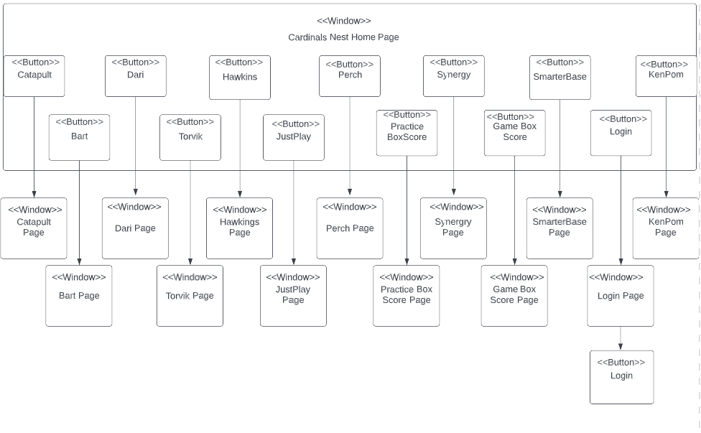

**Data Capture Forms**

These are mockups of the input forms for the screen layout of the new UofL Men’s Basketball Website. Each of the use cases and prototypes presented for the input screen layouts are to portray what the user or administrator should see when they navigate through the website.

**Edit the Home Page Information**

This screen will appear through the administrator's login whenever they access the website to work on the home page. The home page is an important part of the website as it is where users can read reminders and respond with comments, as well as navigate the website through the tabs listed on the navigation bar.

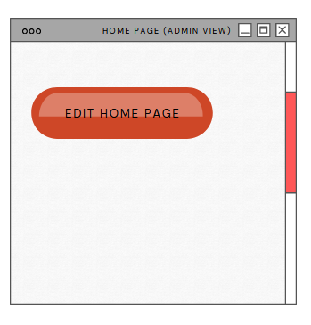

**Create, Edit, and Delete Reminders**

Reminders are an addition to the website that allows admins to display important information to all users when they open the website’s home page. The administrator will be capable of creating the news feed when new information must be shared and have the ability to edit the reminders after the reminders have been created, as well as delete reminders if necessary. The prototype shows the way the reminder input screen layout will be shown for an administrator.

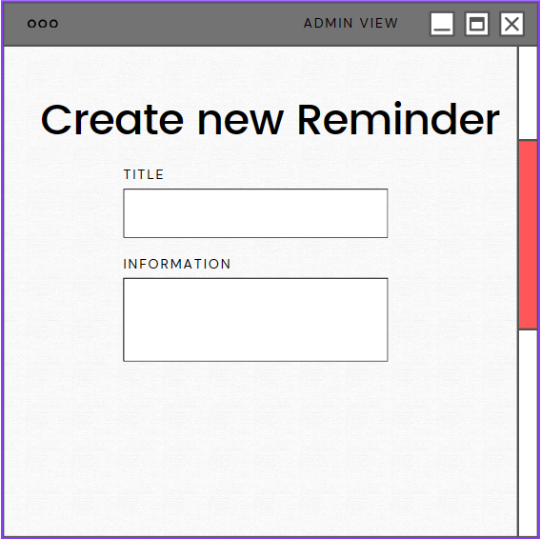

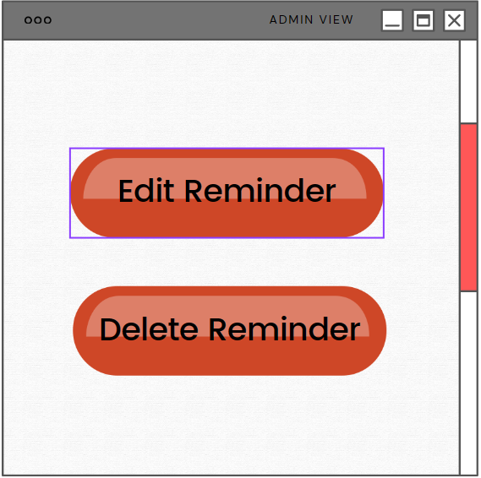

**Create, Edit, and Delete Comment**

Comments are an addition to the website that allows any user to comment on a reminder to communicate with admins regarding important information listed in the reminders. All users will be capable of creating comments under reminders, as well as editing their own comments and deleting them entirely. The prototype shows the way the comment input screen will be shown for all users.

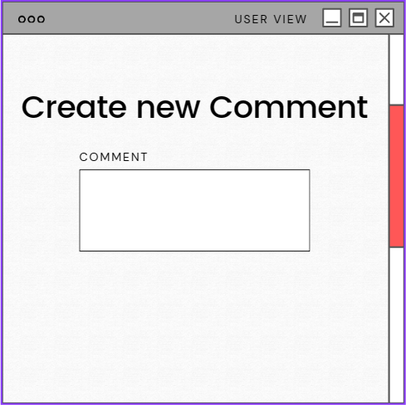

**Edit the Catapult, DARI, Injury Records, Perch Velocity, and Hawkins Dynamic Pages**

This screen will appear through the administrator's login whenever they access the website to work on any of the pages (to input or delete CSV data). The Catapult page is an essential part of the website as it is where users with access can view and compare player data recorded from wearable devices. DARI is useful for motion capture data. The injury records page shows injury data for the players. Perch Velocity measures velocity-based training statistics. Finally, Hawkins Dynamic measures force plate training results for strength and conditioning.

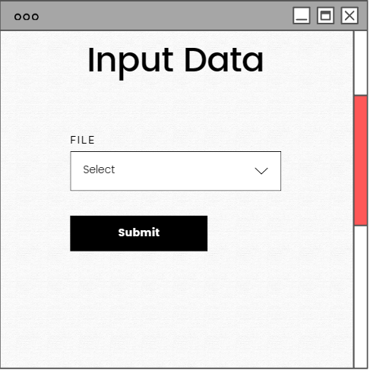

**Create, Edit, and Delete the Catapult, DARI, Injury Records, Perch Velocity, and Hawkins Dynamic Tables**

This screen shows how users and admins can create, edit, or delete a table. Each table will be imported from the external source related to each table as CSV data. Only admins have the power to edit or delete tables or table data. Users can only create tables. Table creation could be done manually if desired, but this is not likely the case. The website view is what the users will see initially. Clicking the link will take you to the database plugin view where you will then manually enter or change the desired values.

Website View:

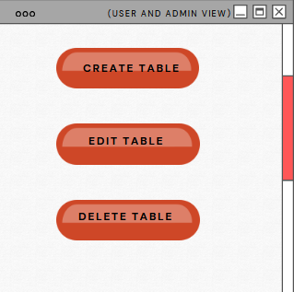

Database Plugin View:

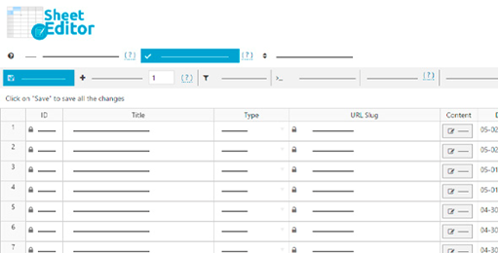

**Create, Edit, Delete Fields: Catapult, DARI, Injury Records, Perch Velocity, Hawkins Dynamics, Practice Box Scores, Game Box Scores**

The Create, Edit, and Delete functions are included on every page that contains a table. This would be the case if a player data field needed to be updated. Only the administrator has the ability to create, update, and delete the data. This layout displays how the administrator will see it when they visit the page. Clicking the link will take you to the database plugin view where you will then manually enter or change the desired values.

Website View:

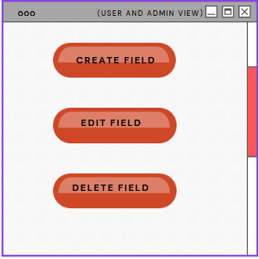

Database Plugin View:



**Create, Edit, Delete Records: Catapult, DARI, Injury Records, Perch Velocity, Hawkins Dynamics, Practice Box Scores, Game Box Scores**

The Create, Edit, and Delete functions are included on every page that contains a table. This would be the case if a player data record needed to be updated. Only the administrator has the ability to create, update, and delete the data. This layout displays how the administrator will see it when they visit the page. Clicking the link will take you to the database plugin view where you will then manually enter or change the desired values.

Website View:

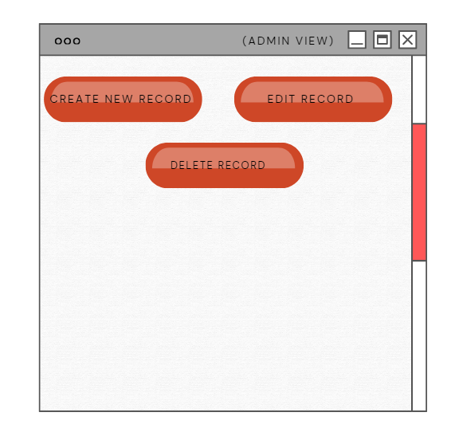

Database Plugin View:



**Create, Edit, Delete Columns: Catapult, DARI, Injury Records, Perch Velocity, Hawkins Dynamics, Practice Box Scores, Game Box Scores**

This would occur when it is necessary to update a column that has inaccurate player information. Both the user and the admin could create, modify, and delete the data. This layout demonstrates how it appears to a user and an administrator. Clicking the link will take you to the database plugin view where you will then manually enter or change the desired values.

Website View:

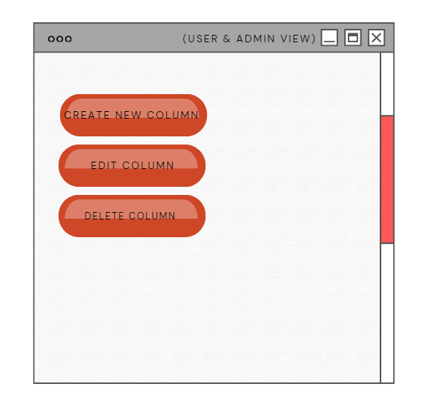

Database Plugin View:



**Create, Edit, Delete Rows: Catapult, DARI, Injury Records, Perch Velocity, Hawkins Dynamics, Practice Box Scores, Game Box Scores**

All pages that contain tables have corresponding Create, Edit, and Delete buttons. This would occur when it was necessary to update a row that included outdated data. The user and the admin can create, change, and delete the data. The user and admin interfaces appear in this layout. Clicking the link will take you to the database plugin view where you will then manually enter or change the desired values.

Website view:

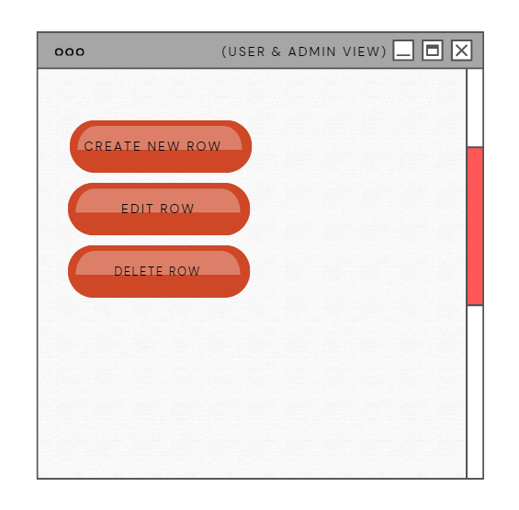

Database Plugin View:



**Create Graph, Change Graph and Delete Graph**

Being able to have control over the graphs such as creating, editing, and deleting graphs is important for the staff to be able to have as much data and statistics as they can. This also creates a big opportunity to organize the data as the staff sees fit.

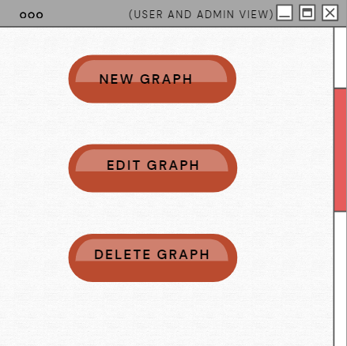

**Search Tool and Function Tool**

The search tool will be able to allow the staff to search for specific charts or graphs, assisting in making the process as efficient as possible. The function tool allows the staff to narrow down the information they will receive when searching through the graphs and tables.

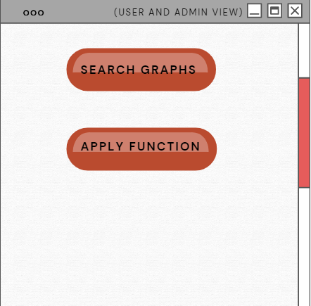

**Link Synergy and SmarterBase**

Synergy and SmarterBase are both important tools to gather information but cannot be fully integrated into the website. The full website allows for the maximum amount of information; therefore, this page will have the link to make it easily accessible.

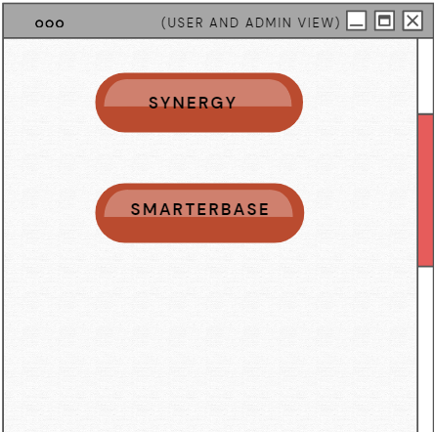

**Input and Edit KenPom Data**

KenPom is a great resource when it comes to gathering data, but offers little help to the website if the data cannot be transferred in. This allows for the KenPom data to be inserted into the website while still being able to edit it if needed.



**Input, Edit, Delete the Practice Box Score and Game Box Score Page**

The practice and game box score pages are important for the players and the team. It shows to the basketball players their weakness, their strength and the areas that need to be improved. The data from those tabs can be input, edited, and deleted by the administrator. This layout shows what it looks like for the administrator when they enter.

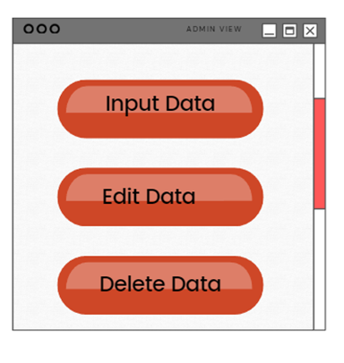

**JustPlay Page**

The users and the admin will be able to access the website by this link. It is important for them to have a user interface friendly and efficient. The first link will directly bring the players to their access portal and the second link will bring the coach and administrator directly to theirs. Just Play is an important role in the life of a college athlete and it helps them get the exposure that they need. The prototype shows the way the just play links will be show for all users.

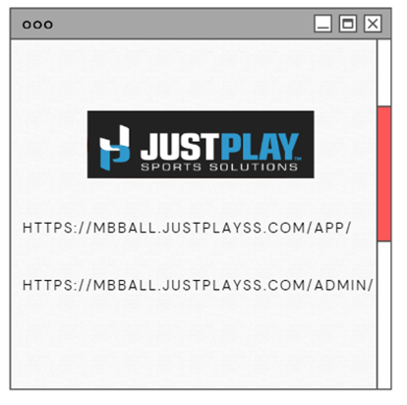

**Data Presentation**

These layouts are mockups of the system’s data presentation, or how the system responds to user input. This includes accepting or rejecting a user from accessing Admin View.

**Admin View Accept/Deny Submission:**

This shows a mockup of how the system will respond to a user trying to login as an admin. Based on what credentials the user enters, the system will accept or reject the user from logging in as an admin.

Accept:

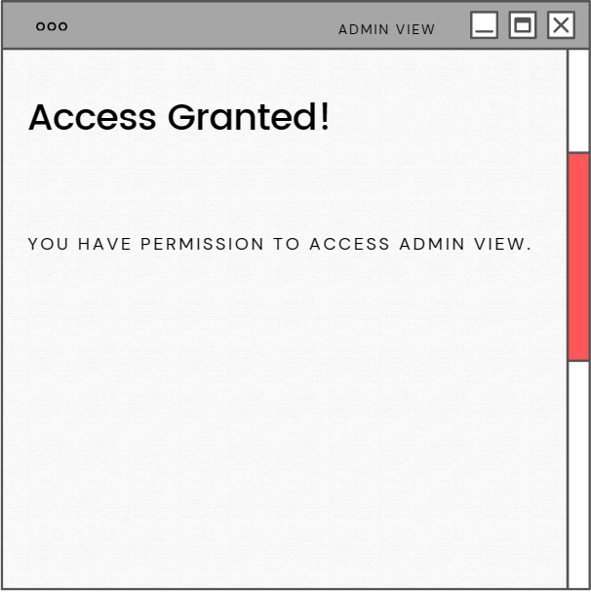

Deny:

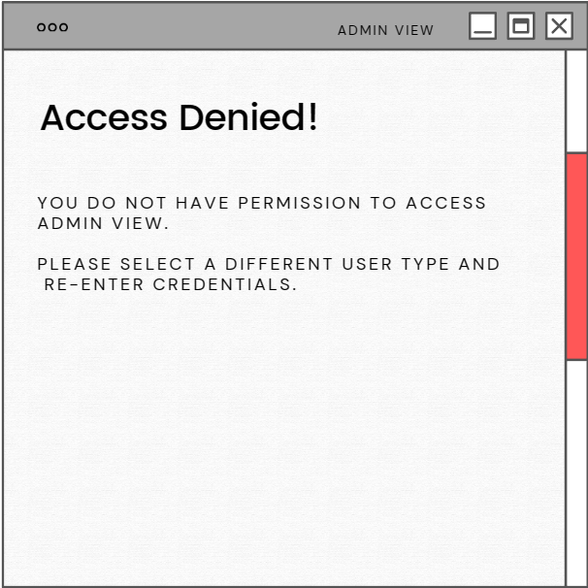

**Gantt Chart**

A Gantt Chart is a tool that is used to help manage the overall workflow of a project. It visualizes which tasks have been started, when they were started, who is working on it or who is assigned to it, what still needs to be done and who still has stuff to do within the project, along with the duration of days each task should take. If used properly a Gantt Chart can become the ultimate tool for project management and a very useful guide to how a project should develop. Our group, TECKS, have used a Gantt Chart to help guide us through the tasks and responsibilities of each member associated with iteration 3, as well as iteration 5 and the elaboration specification.

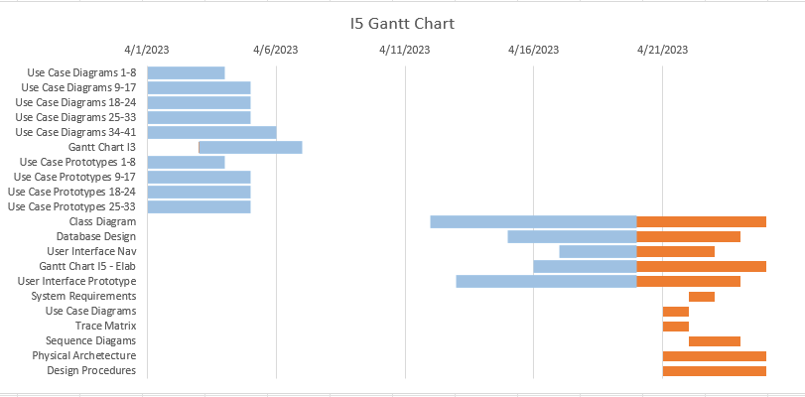

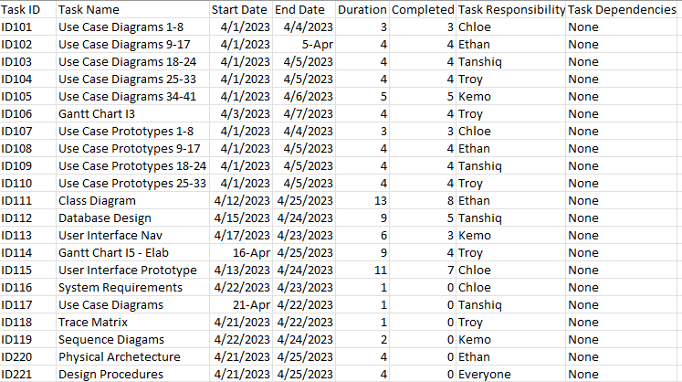

**Physical Architecture Design**

The physical design architecture is displayed above in the diagram. It demonstrates the interconnected systems that users and admins will interface with when accessing the website. The user and admins each have their own workstations that they have access to over a local area network (LAN) connection, or personal devices that can be used to reach the server via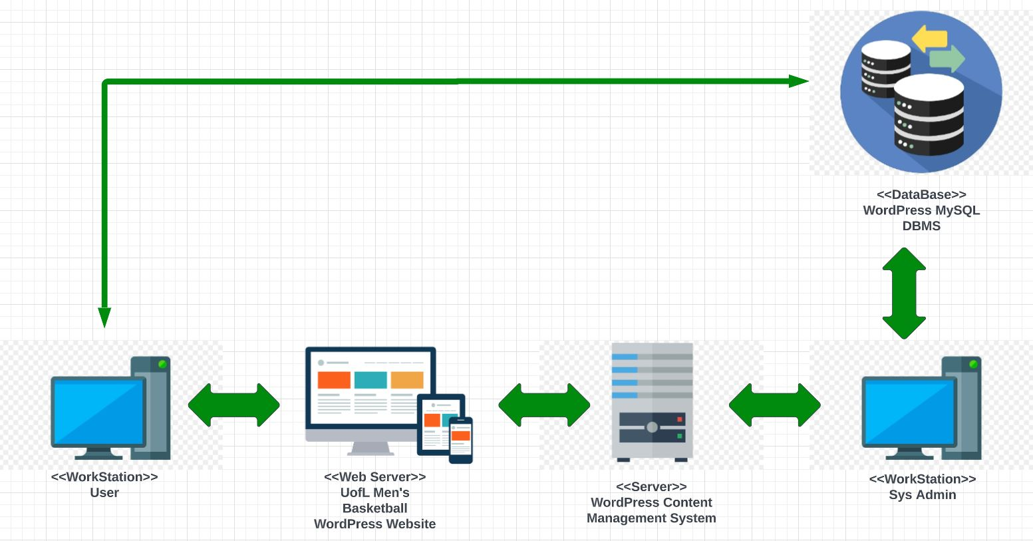 UofL’s own VPN service. Each device will access the UofL men’s basketball WordPress site that is hosted via the WordPress CMS server. Users and admins will also have access to the MySQL database management system that is included with the WordPress Business subscription. Here all of the CSV data will be stored.

**Design Procedures for Security Concerns and Non-Functional Requirements**

The important procedures to be implemented for the nonfunctional requirements include:

* Create a website with paid WordPress account
* Automatic backups to WordPress
* Create secure data input with WordPress plugins
* View and manage data performance throughout the website

This system can be kept secure by making sure that all of the interrelated components are integrated seamlessly. Using a paid version of WordPress will allow for content backup. Using a paid version will also allow the Louisville Basketball Team to easily access technical help 24/7. All types of data can be added onto the website using plugins offered on WordPress. Any risk of data deletion or loss can be combated with the automatic restore feature on WordPress. All content creation and deletion are logged on to WordPress, as well. This will all be kept secure through the administrator’s preceding access.

It is also important that the administrator has access to the website to make sure that it is performing to the best of its abilities. The administrator must monitor the website regularly for technical and performance issues. Users that access the site must have an easy experience navigating through the website with no issues causing it to slow down even with the large amounts of data present on the site. Credentials to login to the site must be kept confidential.

**Elaboration Phase Prototypes**

**Use Case 1, 2, 3, and 4:** Edit Home Page, Create Reminder, Edit Reminder, and Delete Reminder

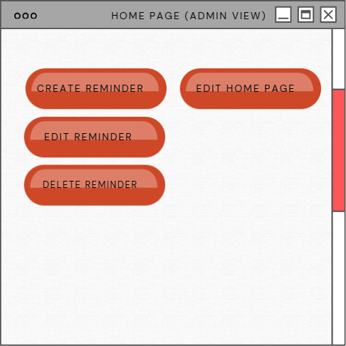

**Use Case 5, 6, and 7:** Create Comment, Edit Comment, and Delete Comment

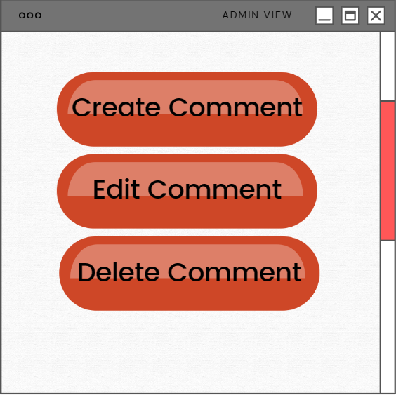

**Use Case 8, 9, and 10:** Input CSV Data, Edit CSV Data, Compare CSV Data

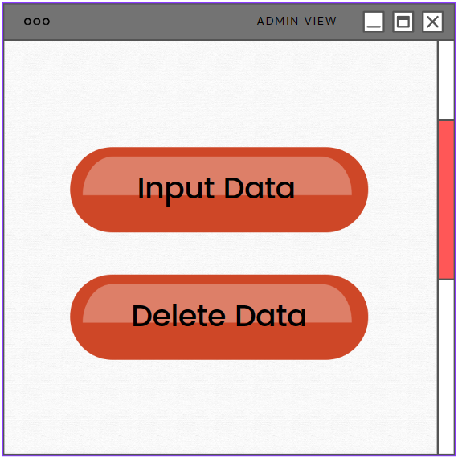

**Use Case 11, 12, and 13:** Create New Table, Edit Table, and Delete Table

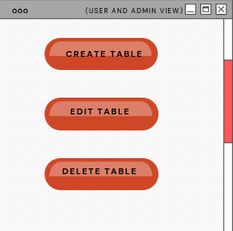

**Use Case 14, 15, and 16:** Create New Field, Edit Field, and Delete Field



**Use Case 16, 17, and 18:** Create New Record, Edit Record, and Delete Record



**Use Case 19, 20, and 21:** Create New Column, Edit Column, and Delete Column



**Use Case 22, 23, and 24:** Create New Row, Edit Row, and Delete Row



**Use Case 25, 26, and 27: Create Graph, Change Graph and Delete Graph**



**Use Case 28 and 29: Search Tool and Function Tool**



**Use Case 30 and 31: Link Synergy and SmarterBase**



**Use Case 32 and 33: Link and Edit KenPom Data**



**Use Case 34 - 37: Link and Edit Bart and Just Play**

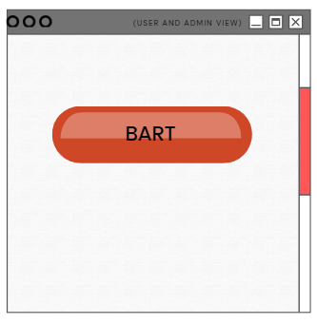



**Use Case 38 and 39: Input and Edit Practice Box Score Data**



**Use Case 40 and 41: Input and Edit Game Box Score Data**

